Using Comparative Charting to Assess Effectiveness of Symptom Management with Home-Based Hospice Patients

Akisha Clark
McAuley School of Nursing, University of Detroit Mercy
NUR 7920: DNP Doctoral Project
Julia Stocker Schneider

Introduction

Hospice is health care that allows someone with a terminal illness to live as well as possible for as long as possible, increasing their quality of life (Hospice Foundation of America, 2018). The goal of hospice care is to address symptom management, care coordination, and patient and family care goals. To be eligible for hospice services, the patient must have a terminal diagnosis with a prognosis of six months or less. Patients who receive hospice care can include those who have received various curative treatments to overcome or promote recovery from an illness. Hospice also serves patients who have rejected aggressive treatment options and have decided to allow the terminal diagnosis to run its natural course. Once a patient has decided to enroll in hospice, the patient is no longer seeking curative treatment measures. The patient and their family embrace comfort care measures encompassed in the end-of-life process. Alexander et al., (2014) asserts that end-of-life treatment decisions can be profoundly difficult for patients and their families.
All hospice providers must comply with the Center for Medicare and Medicaid Services (CMS) regulations. CMS requires that hospice providers must meet the Medicare Conditions of Participation (COP) to be certified and approved for Medicare participation (CMS, 2020). Included in the CMS COP is a requirement for each hospice organization to develop, implement, and maintain effective continuous quality improvement plans to raise performance standards. Additionally, these regulations require hospices to report outcomes data that demonstrates ongoing performance monitoring. However, there are no standards in the COP addressing how the documentation is written in the patient chart.
Quality indicators are outcome measures used to portray the quality of care provided for a specific patient population (Seow et al., 2009). Quality improvement in end-of-life care requires capturing data that truly reflects quality indicators created by the hospice organization. A major barrier to improving quality within hospice organizations is the lack of consistency with how clinical data are recorded and measured. Organization quality indicators should be feasible for nurses to use while providing patient care. Hospices are expected to incorporate quality indicator data, including but not limited to symptom management in any documentation submitted to CMS (CMS, 2020).
Standardized charting tools have been shown to be beneficial in increasing adherence to proper charting of symptom management interventions and patient responses to treatment and efficacy of medication (Bergen-Jackson et al., 2009). However, studies that address the effectiveness of standardized charting in the hospice setting have been limited. Charting in home-based hospice care requires the health professional not only chart the current patient status but also document changes within the patient’s health status. Clinician documentation must support continued delivery of hospice care within the benefit period delineating the decline of patient health. Inadequate charting of symptoms can lead to inaccuracies in quality measurement indicators thereby creating gaps in care, ineffective treatment plans and decreased reimbursement for the provision of hospice services to the healthcare organization. In compliance with government regulations, most hospice providers use electronic health record (EHR) systems to complete charting. Hospices are now required to use a structured, data-driven approach to understand and demonstrate the quality of care they deliver and to develop strategies to improve processes and outcomes of care (Hanson et al., 2010).

Background
In 2018, there were 4,639 Medicare-certified hospice agencies in the United States, a 13.4% increase since 2014. Moreover, 1.55 million Medicare beneficiaries were enrolled in hospice, a 15% increase from 2014 (NHPCO, 2020). There has been a surge of individuals selecting hospice or palliative care treatment plans, resulting in rapid growth of hospice care organizations. This can be attributed to the changing methods of the hospice health care delivery system, patients reporting general dissatisfaction of end-of-life care, cost savings of hospice care, and the desire of patients and their families to spend time with their loved ones.
According to Hansel et al. (2015), CMS issued regulatory changes to support organizations’ use of information obtained from patient care assessments to modify treatment care plans at the time of care. This change was due to previous quality assurance approaches which focused on resolving poor performance problems after care was provided rather than proactively improving care quality. According to CMS (2020), medical records should contain enough clinical factors and descriptive notes to confirm that the illness is terminal and is progressing in a manner that a physician would reasonably conclude that the beneficiary’s life expectancy is six months or less. Hospice benefit periods are unlimited if the life expectancy is less than six months, and the documentation of disease progression is evident. The hospice enrollee must show decline from one benefit period to the next.
Documentation should justify the patient’s eligibility for hospice services based on the physician’s certification of the terminal diagnosis. Clinicians should avoid vague statements of decline which do not clearly support the progressive terminal illness. By providing detailed objective documentation, the patient’s chart contains accurate information when a chart is reviewed by CMS. Additionally, if a hospice chart is audited and the chart lacks documentation supporting a patient’s eligibility, care plan, and treatment, payment can be denied or rescinded by CMS. In 2018, Medicare reimbursed a total of 19.2 billion dollars for 114.0 million days of hospice care (NHPCO, 2020). Loss of revenue poses a problem for the infrastructure of the hospice organization and could affect its operational longevity. The purpose of this quality improvement (QI) project is to determine whether implementation of a standardized charting tool will enhance documentation using comparable charting within a home-based hospice care organization.
Significance of the Problem
Nurses are the largest discipline involved in patient care at this in-home hospice organization. Given this volume, the impact of nurses on the delivery of patient care and patient outcome measures is significant. As such, nurses bear an important burden of responsibility to adequately record patient information. When a nurse fails to accurately document patient care, unnecessary steps in care becomes more likely. For example, a nurse may perform care without knowing the effectiveness of prior medication, resulting in an ineffective intervention and outcome in the patient’s pain management. In addition, undocumented patient health decline between patient care visits has resulted in poor care management. These inadequacies in documentation extends the amount of time it takes to achieve patient comfort.
Hospice care presents unique challenges because most nurses in this organization provide care in the patient’s home. Patients often have complex needs, high acuity and social situations which requires the nurse to handle multiple matters at the bedside. While in the home, the nurse must manage symptoms, provide training to caregivers, and provide emotional support to the grieving family and this takes the ability to chart detailed activities completed at the bedside without structural input.
Variations in medical terminology used by nurses is also problematic. Multiple means of documenting a patient’s pain score are available. However, using pain scales interchangeably is not suggested because their meanings can vary from one scale to the next. Inconsistent use of terminology in an EHR system not constructed for hospice care also adds to the ambiguity of documentation and may reduce the quality of care delivered.
The majority of hospice patients enrolled with the organization are covered under their Medicare Part A Hospice Benefit. Documentation is driven by the Medicare Conditions of Participation under the Code of Federal Regulations, Title 42 and Part 418 (42CFR418) (Bergen-Jackson et al., 2010). Although CMS requires documentation for the matter of compliance and reimbursement, there are no clear set standards of how patient care is documented or recorded. Since there are no clear standards to record patient care, this leaves the hospice agency to set its own policies to obtain, maintain and present clinical patient care information from visit to visit, reinforcing gaps in outcome measures.
In home-based hospice nursing, the availability of a verbal hand-off report typically does not exist. As such, the nurse must obtain all communication about the patient from the patient’s chart. Rarely do opportunities exist for two hospice nurses to share patient report. Although hospice regulation requires bi-weekly interdisciplinary meetings, most informal communication that occurs regarding a patient is not documented within the patient’s chart. Failure to communicate interventions and effectiveness leaves the next provider with little to no information regarding effective and ineffective interventions for the patient. Sisson (2013) reported that a $112 million-dollar settlement was obtained against a San Diego hospice company for submission of false claims for payment. The claim posited that inaccurate documentation led to false claims. Financial losses such as these can be significant and lead to the closure of the organization.
Problem Statement
Standardized comparative charting is not routinely used in hospice care documentation. As a result, nurses are unable to consistently find information needed during the patient visit to perform effective interventions. Additionally, the lack of standardized comparable charting can lead to documentation gaps that may result in potential financial loss for the organization. It can negatively affect hospice patient outcomes measurement, reduce reimbursements for the organization, compromise care for hospice patients, and could possibly even result in costly litigation.
Literature Review
A literature review was conducted to determine the state of evidence regarding the use of comparative charting in hospice documentation. Three databases were searched including CINAHL, the University of Detroit Mercy catalog, and Google Scholar. Inclusion criteria for the study included English language-based research and quality improvement (QI) articles published between March 2010 to January 2021. Initially, the writer searched for “comparative charting” in the hospice setting and was unable to locate any findings. Next, the writer searched for “comparative charting” in other health related settings and was unable to locate any additional findings. Therefore, the search was expanded to include the following search terms; hospice documentation, standardized charting, hospice assessment, symptom management, end-of-life treatment, hospice eligibility, quality measurement, and outcome documentation. Research and QI articles that met the criteria were grouped according to presenting themes. Standardized charting, quality indicators and barriers to comparative charting are the major themes discussed below.
Standardized Charting
Steindal et al. (2011), conducted a quantitative study to compare pain management in 220 patients (110 cancer and 110 non-cancer) in the last three days of life. Nurses used standardized charting while assessing cancer patients for pain. Non-cancer patients were assessed for pain without standardized charting. At the end of the study the assessment data were compared to see if there were any obvious differences in the quality of assessment between cancer and non-cancer patients. The results showed because of the standardize charting, cancer patients’ pain levels were assessed and documented more than non-cancer patients. This study showed that 42% of patients experienced high levels of pain in their last days, with no discernable differences between cancer and non-cancer patient, however cancer patients received more medication coverage for pain control based on the standardized charting recommendations. The findings of this study demonstrate that the use of a standardized assessment tool for pain can improve pain outcomes. Study findings also suggest that standardized charting can improve nurses’ ability to complete assessments in real time and that it can help guide their assessment.
In a study completed by Bergen-Jackson et al. (2009), a randomized trial multifaceted record review involving 16 midwestern hospices to support evidence-based practices with cancer pain management. The study reviewed records from each facility and used the records to gather data related to outcome measures and standardized charting. Information collected from the review of records were then presented to the organizations to use to improve future practices. As a result of their study, it was demonstrated that standardized documentation assisted with the collection of information leading to improved research. Standardization of documentation systems and language also facilitates research in the hospice setting, a population for which advancing knowledge is essential to assure quality care at the end of life (Bergen-Jackson et al., 2009).
Quality Indicators
Bao et al. (2017), completed a qualitative study analyzing how nurses recognize and use quality indicators in the clinical practice. The author interviewed a focus group of twelve nurses regarding nurses’ perceptions related to use of quality indicators to drive results in their nursing unit. Findings demonstrate that nurses believe quality indicators can be effectively used as objectives for setting health care outcomes goals, promoting the improvement of continuous care, and assisting in clinical decision-making.
Morss Dy et al. (2015), in conjunction with the Measuring What Matters Initiative, created a methodological priorities subgroup to address measurements issues and reduce the number of outstanding quality indicators previously related to the palliative care field from its original number of 75 to a reduced number of 10. The results of the study provided a concise, consensus-based set of processes and outcome quality indicators for use in quality measurement and improvement. The identified key quality indicators were screening for physical symptoms and dyspnea; discussion of emotional, psychological, and spiritual concerns; dyspnea management; surrogate documentation; treatment preferences; and consistency of care.
In a quality improvement project, Seow et al. (2009) used quality indicators to improve the care provided for cancer patients. The National Cancer Institute and the Agency for Healthcare Research requested the author to complete the study to develop a framework to be used by network developers for end-of-life care. The project identified ten quality indicators specifically for use within the cancer population, which led to steps to reach benchmark goals in care to improve outcomes. The study demonstrated that quality indicators effectively identify areas and settings most in need of improvement, quality indicators should be reflective of the scope of care, feasible to implement, and should be supported by evidence. They found that by using quality indicators to develop standardized charting tools, the organization can ensure feasibility and reliability in achieving the health organization’s goals.
Barriers to Charting
Vafaei et al. (2018), conducted 20 semi-structured interviews regarding nursing documentation with 18 nurses and two doctors from the emergency department to gain insight into why staff had become less compliant with following the organizational policies for documentation timeliness and accuracy. The interviews consisted of several open-ended questions to allow participants to discuss their perceptions regarding documentation procedures in the emergency department. Conclusions from this study revealed five main categories for barriers to charting within the defined goals of their organization: 1) documentation competency, 2) job burnout, 3) perceived control, 4) intra-organizational coordination, and 5) legal barriers to documentation. Moreover, the findings suggested that there were several subsequent barriers to documentation compliance: lack of effective training programs, poor monitoring from chart audits, usability of existing charting systems, and documentation of patient care which conflicted with the policies of the organization. Furthermore, many assessments were found to be incomplete due to the time it takes to complete documentation at the bedside in conjunction with the workload of the nurse.
Documentation is the leading resource for detailing the care of the patient. However, hospice health professionals continue to struggle to provide accurately detailed charting in the hospice home care arena. Results from a study by Chung et al. (2006), showed that standardized documentation at the point-of-care is needed using electronic forms to help evaluate symptoms and pain that are equivalent to paper instruments currently in use to measure symptoms and pain. The study substituted the organization’s paper forms of standardized assessment with an electronic format in the EHR and analyzed if the electronic format was easier for use by nursing staff. Standardized systems of documentation have proven to be helpful in the past for larger health organizations and many home care agencies.
This review of the evidence was completed by the writer to assess whether a standardized charting tool would impact compliance and affect quality indicators. The literature review expressed themes regarding the barriers to charting in general but failed to specify comparable charting or charting needs in the hospice setting. Findings from this literature review describe barriers and support the use of standardized comparative charting in symptom management and end of life care. This quality improvement project builds on the current evidence and seeks to extend it through the adoption of a comparative charting to improve documentation.
Organizational Assessment
An organizational assessment was completed at a Southeastern Michigan hospice provider. This freestanding organization was originally founded in 1898. It currently services Clinton, Eaton, Ingham, Jackson, Livingston, Macomb, Oakland, Shiawassee, Washtenaw, and Wayne counties in the state of Michigan. The organization employs over 100 professional/para-professional clinicians from all disciplines including registered nurses, licensed practical nurses, physical therapists, physical therapy assistants, social workers, occupational therapists, occupational therapy assistants, speech therapists, dietitians, nurse practitioners, spiritual care specialists, bereavement specialists, and a volunteer coordinator. The mission of the organization is to provide quality care for its patients including symptom management, physical care and grief services. The organization has the goal of increasing patient census, decreasing unnecessary revenue loss, and decreasing/eliminating the number of charts requested by CMS for Additional Documentation Review (ADR).
Regulations from CMS make reimbursement to the organization contingent upon the accuracy of patient charting. Medicare reviewers determine that claims have insufficient documentation errors when the medical documentation submitted is inadequate to support payment for the services billed (CMS, 2017). Nurses have a small window of time to complete charting accurately prior to submission to CMS. Per the Conditions of Participation 418.54(a), the hospice nurse must complete an initial visit and submit the initial assessment within 48 hours of the election of hospice care (CMS, 2020). As with many hospices, this organization struggles at times with missing documentation and resolving documentation issues quickly. When charting requires additions or corrections, chart turnaround time for completion and processing can be extended due to the extra steps required for auditing and rework. An incomplete or inaccurate chart must be returned to the nurse for completion, and then returned to the audit team for additional charting review. The agency must factor for not only the increased turnaround time, but also the increased use of manpower required to complete redundant chart audits.
Another problem faced by the organization is potential loss of revenue due to additional documentation reviews from CMS. When charts are denied for inadequate charting or inaccuracy, the organization can be required to reimburse CMS monies received for patient care. Like other hospice organizations, this organization wishes to maintain accurate, timely, and complete documentation to minimize financial risk, maintain adherence to CMS regulations, and support the delivery of high-quality hospice care.
These factors were instrumental in assessing the organization’s readiness for change. Readiness for change was observed related to the staff buy-in to complete this QI project. The writer observed a shared viewpoint by the organization to reduce barriers to comparative charting by ensuring documentation is complete and accurate to support better clinical decision making and care, using processes that are more efficient and requires less rework. The leadership stakeholders were motivated to drive improvement related to regulatory, financial, and organization sustainability.
The organization recognized the need to ensure that all required elements necessary for the delivery of high quality of care are documented. “The development of a standardized documentation system is part of the intentional, and oftentimes third-party payor-imposed progression of healthcare organizational change and growth” (Bergen-Jackson et al., 2009, p.336). Standardized documentation has proven beneficial in performing comprehensive assessments and improving outcome measurement for health organizations. It would be an easy transition to use a standardized method to ensure documentation includes patient assessment, patient presentation, and nurse intervention outcomes leading to improvements in patient care quality indicators.
Process, Facilitators, and Barriers
Several quality improvement tools were used to determine current comparative charting practices and barriers to their use within the organization. The investigation tools operationalized were: 1) stakeholder questionnaire, 2) cause-effect diagram, 3) process map, 4) driver diagram, and 5) “5 whys” assessment. The writer obtained some of the aforementioned tools from the Institute for Healthcare Improvement (IHI) website (2021). These tools provided a platform for the writer to analyze potential barriers to comparative charting, investigate possible reasons for the barriers, and to execute an evidenced-based intervention to reduce barriers.
Stakeholder Questionnaire
The first quality improvement tool applied by the writer was a brief questionnaire distributed to nursing staff to assess their barriers to charting while at the bedside. The questionnaire allowed nurses to provide open-ended discussion regarding the barriers they face with documentation. Six nurses were questioned and were able to respond to the questionnaire freely without any constructive guidelines. The main question asked via email to the six participating nurses was “What are the barriers you face in the field to charting?” Please refer to the appendix A to view the stakeholder questionnaire. As the project progressed, the writer narrowed the focus to the two most frequently reported barriers to charting while at the bedside which were: training and equipment.
Fishbone Diagram
The writer analyzed results from the stakeholder questionnaire by identifying emerging themes regarding the identified causes for charting inadequacies. A fishbone diagram was created to summarize the identified themes and causes (see Appendix B). Themes identified in the fishbone graph were people, training, equipment and policies. Policies and equipment in the opinion of the writer would need grand scale changes to be implemented. The writer reduced themes to the those having the greatest impact for change within the design timeline and having the least financial impact on the organization which were people and training. Upon analysis of the completed fishbone diagram, the themes were reduced to two main contributing factors: “lack of training” and “limitations of the EHR” which were identified as comparative charting barriers. Resolving these barriers would have the greatest mitigation impact on comparative charting.
Process Map
After collecting the information from the questionnaire, the writer sought to understand the process nurses follow to complete charting. See Appendix C for the process map which begins with the patient being admitted to hospice services. The writer passively observed the nurse-assessment process and completed a process map. The writer noted nurses lacked a succinct, direct, and detailed standardized documentation method for the interventions performed. To confirm the findings, the writer then reviewed the processes for evaluating nursing interventions and reviewing comparable charting with the organization’s management. Although the EHR allows the nurse to document comparative data on the patient’s status, it is not structured to encourage comparative charting. As a result, comparative charting is not consistently or routinely completed by all clinical nursing staff.
Process Driver Identification Tools
The writer secured a template from the IHI website (2021), called the “Driver Diagram” to use as a visual display of the theory of the project aim. The aim was placed in the first column. The writer looked at primary drivers or motivation for the aim which were written in descending columns. Please see Appendix D to review the driver diagram. Information was entered on a driver diagram worksheet and “the 5 whys” worksheet, both of which were also located on the IHI website in the quality-improvement section. The driver diagram provided additional confirmation of the need for training and standardized documentation.
The 5 Whys Worksheet
The writer obtained the QI worksheet called the “5 Whys” to further reveal the barriers to charting. Please refer to the appendix E to review the 5-Whys Worksheet. The writer placed the event or problem in the first box of the worksheet. Next, the problem was defined as a pattern and the team then looked at reasons the pattern was occurring. Findings revealed that these patterns can lead to poor performance, increased time in chart audits and negatively impacted communication between disciplines.
Use of QI Tool Findings
The writer presented QI applications to the chief nursing officer of the organization for validation. A QI project team consisted of members from the leadership and nursing teams was formulated. Data presented from the QI applications were used to create goals for the organization within the scope of the QI project. All data collected from the findings of the QI tools previously mentioned were reviewed by the chief nursing officer of the organization and used to formulate the QI project intervention to create change with and increase use of comparative charting. Please refer to Appendix F to view the PDSA plan.
Theoretical Framework
This QI project incorporated W. Edward Deming’s Model for Improvement based on Deming’s work. The QI project focused on increasing the amount of comparative charting completed by the nursing staff. The Deming cycle focuses on continual improvement known as the Plan, Do, Study, Act (PDSA) cycle. According to Nelson, Batalden, and Godfrey (2007), improvement requires learning grounded in the experience and daily reality of the work of health care in that frontline context. Deming’s Model for Improvement complemented the project’s implementation of a standardized charting tool for comparative charting and quality indicators. Information obtained from the PDSA cycle was analyzed and funneled back into the project to see if the study reinforced agents of change within the organization. To ascertain if the intervention constituted an improvement, this study incorporated various measures for assessing change and evaluation.
Purpose Statement/Goals and Objectives
This QI project attempts to determine if the use of a standardized comparative charting tool will increase adherence to comparative charting focusing on pain management and shortness of breath with patients enrolled in hospice services in their home setting. According to the CMS State Surveyors Operations Manual (2020), the comprehensive assessment must include data elements that allow for measurement of outcomes. The hospice must measure and document data in the same way for all patients. The data elements must take into consideration aspects of care related to hospice and palliation. Some of the most common symptoms assessed that could benefit from comparative charting are pain and shortness of breath (SOB). By focusing on the patient’s pain and shortness of breath documentation, the QI project delineated precise measurement outcomes. The nature of hospice care and hospice’s home-based setting present unique challenges to documentation. The specific aim of the project was to increase compliance with comparative charting in the electronic health record “free-text” section for pain management and shortness of breath by 30% after 4 weeks of the implementation of a standardized comparative charting tool.
Methods/Design
Based on the findings of the quality improvement tools, the decision was made to introduce a comparative charting tool to standardize documentation. By introducing the Comparative Charting Tool (CCT), this QI project assisted the nurse in charting current vs. past observations, therefore providing a more detailed note of the patient’s condition and thereby meet CMS documentation requirements. The process map revealed that nurses needed an easy-to-use, on-the-go tool to support comparative charting at the bedside or remotely when charting patient’s assessment and interventions. Knowledge obtained from quality improvement applications were used to create and implement a standardized scripted tool for use in practice.
Implementation
First, the writer conducted chart reviews of 28 randomly selected patient charts to provide baseline data for SOB and pain intervention/effectiveness documentation, time indicator uses, comparative charting occurrences and additional chart editing requirements. Next, the writer distributed pre-surveys to assess the nurses’ knowledge prior to the intervention. Pre-surveys were completed using Google forms. The writer emailed a link to the survey to all nursing staff with instructions. Nurses were given one week to complete the survey. The writer sent a reminder email for nurses to complete the survey after three days.
Next, the writer hosted a Zoom briefing session to initiate the intervention with the support and assistance of the organization’s leadership. The meeting was conducted both in-person and via the organization’s teleconference platform, allowing additional accessibility to promote the nurses’ attendance. During the education/briefing session, the writer discussed the importance of completing the pre-survey, the problem the QI project hoped to address, goals for change by the organization, and instructions on how to use the CCT while in the field. While participation was voluntary, it was the goal of the QI project to obtain 100% participation. This goal was met with participation of all seven members of the nursing team.
The intervention started immediately after the introductory Zoom session on June 3, 2021 with an end date for the pilot of July 3, 2021. All nursing staff received a laminated copy of the comparative charting tool which consists of examples and prompts of time indications. The tool provides the sentence structure needed for comparative charting with examples and suggestions to guide the nurse while charting in the free text areas of the EHR (see Appendix G to view the comparative charting tool). Nurses were instructed to use the tool while charting. All seven nurses on the nursing team trialed the comparative charting tool during patient assessments for the duration of the intervention span. At the end of the four-week intervention period, the writer conducted post-intervention chart reviews. Concluding the intervention, the writer hosted a debriefing session via the same Zoom platform to discuss the intervention, the post-survey results, and its sustainability. The writer gathered data, completed an analysis, and posted results for the entire organization to review.
Debriefing Session
Results of the QI project were presented to the entire organization in a debriefing session which was held following the completion of the project implementation and evaluation. The presentation included a summary of the project results including chart audit and survey findings as well as project evaluation data. The debriefing session concluded with an in-person meeting with options to attend via teleconference and was accessible to all staff in the organization.
Ethical Consideration
This was a quality improvement project and not a research study. Participation in the QI project was voluntary. Patient consent was not required, as data obtained did not include any patient identifiers. Data obtained consisted of chart audit data to determine if the intervention improved comparative charting which was reported only in the aggregate. Staff and patient’s data collected were de-identified and were kept confidential. Survey responses obtained from nursing staff did not include any identifiable information and nurses were able to reply to the surveys anonymously. Chart reviews did not include any patient identifiers.
Evaluation Methods
Data Collection Tools
Chart Audits
To assess the impact of the intervention, the writer randomly selected 28 patient charts to review prior to the implementation of the intervention to obtain a baseline. Inclusion criteria for the audit were patients admitted for at least 14 days. Patients with a diagnosis of Alzheimer’s disease, dementia, or brain cancer were excluded. Additionally, patient charts with no symptom management interventions required were also excluded. Following the intervention, an additional 28 patient charts audits were completed using the same inclusion criteria and random selection. All patient charts were reviewed by the same reviewer in a consistent manner using percentages to delineate scale options. Charts tallied with 0% were scaled as “never”. Charts with 1-49% were scaled as “rarely”. Charts with 50-99% were scaled as “sometimes” and charts scaled to “always” were 100%. Appendix H displays the chart audit tool and scale used to evaluate.
Surveys
Pre- and post-surveys (see Appendix I) were given to the nursing team before and after implementation of the intervention. The goal of the pre-survey was to assess nursing staff knowledge of comparative charting, to assess barriers to comparative charting, and to explore nurse perceptions regarding charting. The goal of the post-survey was to determine whether the intervention increased the nurses’ knowledge of comparative charting, identify additional barriers that may have presented during the intervention, and to assess nurses’ perceptions of use of the comparative charting tool in practice.
An email was sent to the nurses to invite them to participate of the pre-survey. All nurses received the Google Forms link via email from the Google Forms platform. Once the survey link was received, the nursing staff had one week to complete the survey. A reminder email was sent 3 days prior to the final completion date to encourage participation. The post-survey was administered in the same manner as the pre-survey. Surveys are a non-threatening way to obtain the viewpoints of the end user. By using platforms such as Google Form accurate data can be obtained at no additional cost to the organization.
Analysis
Specific Aim
To determine if the specific aim was achieved, pre-implementation and post-implementations audits were compared to examine differences in frequency to see if there was an increase in comparative charting in the electronic health record “free-text” section for pain management and shortness of breath.
Chart Audits
To analyze differences in the pre- and post- implementation chart audits, Wilcoxon signed-rank test was used to analyze the items with ordinal data. The Wilcoxon signed-rank rest was selected because it accepts non-parametric hypothesis using two populations of matched examples and assumes the data is not normally distributed which was appropriate given the small sample size (Refugio, 2018). For the three items that generated nominal data, McNemar’s Chi-squared test was selected as the best test to analyze the matched pair data (Onchiri, 2013).
Nurse Surveys
Pre- and post-intervention survey data were compared to determine if there was a change in nurse perception of comparative charting before and after the intervention. The Wilcoxon signed-rank test was used to analyze these ordinal pre- and post-survey results to determine if the changes were significant.
Results
Specific Aim
A review of the pre-implementation chart audit showed that comparative charting occurred in the free text area “always” or “sometimes” 18 percent of the time. Following implementation of the Comparative Charting Tool, comparative charting occurring in the free-text area “always” or “sometimes” 75 percent or the time. Thus, the project’s specific aim of increasing compliance with comparative charting in the electronic health record “free-text” section for pain management and shortness of breath by 30% after 4 weeks following implementation of the standardized comparative charting tool was met and exceeded.
Pre- and Post-Implementation Chart Audits
See Table 1 for comparison of pre-and post-implementation chart audits of nurse documentation for all ordinal measures. Differences in comparative charting following the intervention were statistically significant for all ordinal items at the p ≤ 0.05 level.
Table 1
Use of Comparative Charting
 |  | Number of Responses  Pre (28) | Number of Responses  Post (28) | Mdn. | V | z | P value
Pain intervention and effectiveness was documented during the benefit period | Never  Rarely  Sometimes  Always | 6  5  8  9 | 10  3  9  6 | Pre=2.00 Post=4.00 | 59.00 | -2.00 | 0.045
SOB intervention and effectiveness was documented during the benefit period | Never  Rarely  Sometimes  Always | 12  5  7  4 | 12  3  9  4 | Pre=2.50 Post=2.00 | 148.00 | -2.21 | 0.027
Comparative charting was present in the free text areas | Never  Rarely  Sometimes  Always | 10  13  5  0 | 1  6  12  9 | Pre=2.00 Post=4.00 | 59.00 | -2.00 | 0.045
A time indicator was used in the free text areas | Never  Rarely  Sometimes  Always | 6  9  13  0 | 1  3  14  10 | Pre=2.00 Post=1.00 | 180.00 | -3.90 | <0.001

Please refer to Table 2 for chart audit results for all categorical measures. The results revealed that nearly all patients were screened for pain and shortness of breath (SOB) at the initial evaluation. Due to the near universal compliance with this documentation standard, those items could not be analyzed statistically due to the lack of variability in the data. The pre- and post-intervention chart audit comparison did reveal a statistically significant reduction (p≤0.05) in the number of charts that required additional editing following the implementation of the Comparative Charting Tool (CCT).

Table 2
Use of Comparative Charting, questions 1, 2, and 7
 |  | Number of Responses  Pre (28) | Number of Responses  Post (28) | X^2(1). | P value
Patient was screened for pain during the initial evaluation | Yes  No | 27  1 | 28  0 | NA | NA
Patient was screened for SOB during the initial evaluation | Yes  No | 28  0 | 28  0 | NA | NA
Based on this chart audit, does this chart require additional edit | Yes  No | 26  2 | 7  21 | 19 | <0.001

Nurse Pre- and Post-Intervention Surveys
Please see Table 3 for findings of the analysis comparing the post-intervention surveys to and pre-intervention surveys. According to the analysis using the Wilcoxon signed rank test, none of the differences in nurse perceptions about charting practices were statistically significant at the p ≤0.05 level.
Table 3
Nurse Perceptions of Charting
 |  | Number of Responses  Pre (8) | Number of Responses  Post (9) | Mdn. | V | z | P value
I feel charting reduces the amount of time I have for patient care | Never  Rarely  Sometimes  Often  Always | 2  2  1  2  1 | 1  2  5  1  0 | Pre=2.50 Post=2.00 | 11.00 | 0.96 | 0.336
I complete my charting for the visit in the patient's home | Never  Rarely  Sometimes  Often  Always | 5  1  2  0  0 | 2  4  3  0  0 | Pre=1.00 Post=1.50 | 7.00 | -0.14 | 0.888
I chart "visit to visit" changes in the patient's health condition in the patient's chart | Never  Rarely  Sometimes  Often  Always | 1  0  0  4  3 | 0  0  4  3  2 | Pre=2.00 Post=2.00 | 1.5 | -0.82 | 0.414
I chart the patient's pain intervention effectiveness and SOB intervention effectiveness | Never  Rarely  Sometimes  Often  Always | 0  0  0  1  7 | 0  0  0  4  5 | Pre=1.00 Post=1.00 | 2.5 | -1 | 0.317
I know what is expected in my charting | Never  Rarely  Sometimes  Often  Always | 0  1  0  1  6 | 0  0  1  4  4 | Pre=1.00 Post=2.50 | 4.50 | -1.30 | 0.194

Discussion
The results of the chart audit revealed that the implementation of the CCT was effective in increasing the frequency of comparative charting for the targeted areas of pain management and shortness of breath. Additionally, the inclusion of a time indicator in the free text area of the chart increased by 38%. As previously discussed in the study by Steindal et al. (2011), standardize charting methods guides nurse assessment and improves accuracy of the documentation. Improvement of documentation of pain interventions and effectiveness and SOB intervention and effectiveness was evident in the chart audits following adoption of the CCT. As a result of this QI project, the organization also experienced a 65% reduction in the number of recommended charts edited due to missing information regarding pain and SOB status.
It is clear that this quality improvement initiative had impact on changing nurse practices regarding the use of comparative charting for pain and SOB status as noted by the chart audit findings. Prior to implementation of the project, only 50% of the nursing staff used comparative charting in these targeted areas at some time while charting. After the project, 90% of the nursing staff used comparative charting for pain and SOB at some time in the 4 weeks of implementation.
While not statistically significant, a review of the survey results provided insight into the nurses’ perspectives on comparative charting. It was interesting to note that on the initial survey that most nurses reported that they did chart “visit to visit” changes and pain and SOB intervention effectiveness, but that their perceptions related to doing this decreased rather than increased during the intervention period. This change likely reflects an increased understanding by the nurses of documentation expectations for comparative charting, and therefore a reappraisal of their comparative charting frequency. In a similar manner, the survey demonstrated limited change in nurse perception of charting “visit to visit” changes. However, chart audit results contradict this showing increased comparative charting from “visit to visit”. The nurses’ improved understanding of comparative charting requirements coupled with the small sample size contributed to the lack of statistical significance in the survey findings.
It is presumed that the CCT intervention did not greatly impact nurses’ frequency of charting in the home or perceptions of documentation burden. This hospice organization, like many others, encourages charting at the bedside to improve accuracy and reduce charting time outside the patient’s home. While it was hoped that charting in the home would increase, the CCT did not provide any direct support for this beyond education.
It should be noted that the comparative charting tool implemented for this project did not directly provide changes to the Electronic Health Record (EHR) to provide a space and requirement for comparative charting. Rather, it provided an external tool prompt to serve as a reminder to nurses to show how and when to chart comparatively to support the adoption of new habits for documentation. This simple workaround was selected by the improvement team for this project since alterations to the EHR to accommodate specific prompts for comparative charting would have been too costly for the organization. However, direct incorporation of comparative charting into the EHR would provide more consistency to the process than an external tool for nurses to refer to ever could. Additionally, the EHR could aggregate pain and SOB measures so that trends could be displayed beyond just a visit-to-visit comparison, thus providing the nurse with more insight on patient status and symptom management. According to Yanamadala et al. (2016), “Studies have suggested that EHRs have the potential to decrease medical errors by providing improved access to necessary information, better communication and integration of care between different providers and visits, and more efficient documentation and monitoring” (p. 1). EHRs can impact care quality in hospice particularly if they are structure to meet the specialty need for hospice care (Holup et al. 2013).
Sustainability
Given the initial success of the CCT in meeting the specific aim for this improvement project during the PDSA initial period, the CCT will continue to be used by the nurses in practice. Outcomes will need to continue to be monitored to see if gains are maintained. Chart audits will be continued to assess if the nurses are continuing to comparative chart. If nurses begin to revert to previous charting behaviors additional PDSAs will be completed to assess and eliminate barriers.
CAHPS Scores
To further measure our progress, we will use The Consumer Assessment for Healthcare Provider and Systems (CAHPS). CAHPS for hospice gathers information from family members of hospice patients several months after the patients’ death. The Agency for Healthcare Research and Quality (AHRQ) developed the survey using rigorous scientific processes including literature reviews, cognitive interviews, consumer focus groups, three-state pilot test, psychometric analyses, consumer testing and numerous small-scale field tests to evaluate reliability (CMS, 2019). Participating hospices are required to gather CAHPS data and submit to CMS. It was the intent that select CAHPs measures would be used to assess if the comparative charting intervention made a difference in patient experience in pain and symptom management., Please refer to appendix J to see CAHPS measures. Unfortunately, CMS placed the CAHPS program on hold in 2020 due to impacts from COVID 19. When the CAHPS program is reinstated (projected to resume in late 2021/early 2022), these measures will be used to see if there were any impacts.
Implications for Practice
The results of this improvement project demonstrate that use of the standardizing comparative charting fulfills the organization’s expectations of documentation and gives nurses the opportunity to facilitate accurate, precise, and detailed documentation. Comparative charting is more in line with CMS regulations and reduces jeopardy of the losing reimbursement for the organization. If hospice agencies implement techniques that support the adoption of standardized comparative charting, it can lead to more precise documentation of patient care and improve information accessibility within the organization. While the methods used in this study did result in an improvement in comparative charting, the project highlighted an obvious need for the EHR to support standardized comparative charting by structuring information systems to readily display and collect comparative data in real-time.
Standardized comparative charting can be utilized in other areas of hospice nursing documentation such as patient mobility, wound care protocols, and psychological care aspects. Use of standardized comparative charting can become the gold standard in patient documentation for hospice practice by providing a functional, user-friendly process for documentation, a definitive evaluation of outcomes, providing opportunities for the organization to have regular assessment of documentation. Standardized comparative charting does not extend manpower time, while ensuring nurse documentation is regulatory compliant and ensures fiscal responsibility by the organization. The results of this project demonstrated additional benefits such as increased visibility of nursing interventions, improved patient care, and better communication amongst the nursing team.
Conclusion
The Comparative Charting Tool (CCT) proved to be a benefit to the organization where the project was implemented. Findings suggest advantageous impact to nurse’s charting, ease of use and feasibility of use in the real world. The CCT tool provides simple, direct, and concise sentence structure that allows for the nurse to chart patient health changes from previous visits, which is important and mandatory in hospice charting. The CCT also provides a baseline model for charting to meet expectations and requirements of CMS. This project lends additional evidence to the standardized charting discussion amongst health professionals. Further, it demonstrates the need for standardized comparative charting to be incorporated in electronic health records to support further improvement in documentation to support quality of patient care.

References
Alexander, S., Ladwig, S., Norton, S., Gramling, D., Davis, K., Metzger, M., Deluca, J., & Grambling, R. (2014). Emotional distress and compassionate responses in palliative care decision-making consultations. Journal of Palliative Medicine. 17(5), 578-584.
Bao, A., Amestoy, S., Sonto de Moura, G., & Trindade, L. (2019). Quality Indicators: tool for the management of best practices in health. Revista Brasileria de Enfermagem. 72(2), 378-385.
Barnes, S., Waterman, M., MacIntyre, D., Coughenour, J., and Kessel, J. (2010). Impact of standardized trauma documentation to the hospital's bottom line. Surgery. 148 (4) 793-798
Bergen-Jackson, K., Sanders, S., Herr, K., Fine, P., Titler, M., Forcucci, C., Reyes, J., & McNichol, P. (2009). Determining community provider practices in hospices. The challenges of documentation. 11(6), 334-341
Cagle, J., Rokoske, F., Durham, D., Schenck, P. A., Spence, C., & Henson, L. (2015). Use of electronic documentation for quality improvement in hospice. American Journal Medicine Quality. 27 (4), 282-290
Center for Medicare and Medicaid Services. (2020). CAHPS Hospice Survey. CMS.gov. https://www.cms.gov/Research-Statistics-Data-and-Systems/Research/CAHPS/CAHPS-Hospice-Survey
Center for Medicare and Medicaid Services. (2020). State Surveyors Operations Manual. pdf
Center for Medicare and Medicaid Services. (2017). Medicare Learning Fact Sheet. pdf
Chung, K., Bell, R. & Lee, D. (2006). A point of care clinical documentation system for hospice care providers. Journal of Medical Systems. 30, 33–37. https://doi.org/10.1007/s10916-006-7401-4
Curtis, R., Sathitratanacheewin, S., Starks, H., Lee, R., Kross, E., Downey, L., Sibley, J., Lober, W., Loggers, E., Fausto, L., Lindvall, C., & Engelberg, R. (2018). Using electronic health records for quality measurement and accountability in care of the seriously ill: opportunities and challenges. Journal of Palliative Medicine. 21(S2). https://doi.org/10.1089/jpm.2017.0542
Dudgeon, D. (2017). The impact of measuring patient-reported outcome measures on quality of and access to palliative care. Journal of Palliative Medicine. 21(S2). https://doi.org/10.1089/jpm.2017.0447
Dy, M. S., Herr, K., Bernacki, R., Kamal, A., Walling, A., Ersek, M., & Norton, S. (2016). Methodological research priorities in palliative care and hospice quality measurement. Journal of Pain and Symptom Management. 51(2), 155-162
Dy, M. S., Kiley, K., Ast, K., Lupu, D., Norton, S., McMillian, S., Herr, K., Rotella, J., & Casarett, D. (2015). Measuring what matters: Top-ranked quality indicators for hospice and palliative care from the American academy of hospice and palliative medicine and hospice and palliative nurses association. Journal of Pain and Symptom Management. 49(4), 773-781
Gozalo, P., Teno, J., & Spence, C. (2017). Hospice visit patterns in the last seven days of life and the service intensity add-on payment. Journal of Palliative Medicine. 20 (12), 1378-1384
Hansen, G. A., Martin, E., Jones, L. B., & Pomeroy, E. (2015). Social work assessment notes: A comprehensive outcomes-based hospice documentation system. Health and Social Work. 40(3), 191-200
Hanson, L., Schenck, A., Rokoske, F., Abernathy, A., Kutner, J., Spence, C., & Person, L. J. (2010). Hospices preparation and practices for quality measurement. Journal of Pain and Symptoms. 39 (1), 1-8
Holup, A. A., Dobbs, D., Meng, H., & Hyer, K. (2013). Facility characteristics associated with the use of electronic health records in residential care facilities. Journal of the American Medical Informatics Association: JAMIA, 20(4), 787–791. https://doi.org/10.1136/amiajnl-2012-001564 Institute for Healthcare Improvement. (2021). Tools. IHI. http://www.ihi.org/resources/Pages/Tools/default.aspx
Kamal, A., Nicolla, J., & Power, S. (2017). Quality improvement pearls for the palliative care and hospice professional. The Journal of Pain and Symptom Management. 54(5), 758-765. https://doi.org/10.1016/j.jpainsymman.2017.07.040
Kamal, A., Bull, J., Kavalieratos, D., Nicolla, J., Roe, L., Adams, M., & Abernathy, A. (2016). Development of the quality data collection tool for prospective quality assessment and reporting in palliative care. Journal of Palliative Medicine. 19(11). https://doi.org/10.1089/jpm.2016.0036
Kamal, A., Kavalieratos, D., Bull, J., Stinson, C., Nicolla, J., & Abernathy, A. (2015). Usability and acceptability of the QDACT-PC, an electronic point-of-care system for standardized quality monitoring in palliative care. Journal of Pain and Symptom Management. 50 (5), 615-621
Kamal, A., Hanson, L.,Casarett, D., Dy, S., Pantilat, S., Lupu, S., Abernethy, A. (2015). The quality imperative for palliative care. The Journal of Pain and Symptom Management. 49(2), 243-253. https://doi.org/10.1016/j.jpainsymman.2014.06.008
Kamal, A., Bull, J., Ritchie, C., Kutner, J., Hanson, L., Friedman, F., Taylor, D., & The AAHPM Research Committee. (2015). Adherence to measuring what matters measures using point-of-care data collection across diverse clinical settings. Journal of Pain and Symptom Management, 51(3), 499-503
Kamal, A., Nipp, R., Bull, J., Stinson, C., Lowery, A.,Nicolla, J., & Abernathy, A. (2015). Quality of palliative care for patients with advanced cancer in a community consortium. Journal of Pain and Symptom Management. 49(2), 289-292. https://doi.org/10.1016/j.jpainsymman.2014.05.024
Kamal, A., Harrison, K., Bakitas, M., Dionne-Odom, J. N., Zubkoff, L., Akyar, I., Pantilat, S., O'Riordan, D., Bragg, A., Bischoff, & Bull, J. (2015). Improving quality of palliative care through national and regional collaboration efforts. Cancer Control. 22(4), 396-402. https://doi.org/10.1177%2F107327481502200405
Kamal, A., Bull, J., Stinson, C., Blue, D., Smith, R., Hooper, R., Kelly, M., Kinsella, J., Philbrick, M., Gblokpor, A., Wheeler, J., Downey, W., & Abernathy, A. (2011). Collecting data on quality is feasible in community-based palliative care. Journal of Pain and Symptom Management. 42(5), 663-667
Leff, B., Carlson, C., Saliba, D., & Ritchie, C. (2015). The invisible homebound: Setting quality of care standards for home based primary and palliative care. Health Affairs. 34(1). https://doi.org/10.1377/hlthaff.2014.1008
Nation, L. (2019). Using the international classification of functioning, disability and health to document hospice eligibility. Journal of Hospice and Palliative Nursing. 21(3), 237-244
National Hospice and Palliative Care Program. (2021). Hospice Quality Public Reporting. https://www.nhpco.org/regulatory-and-quality/quality/hospice-quality-public-reporting-hospice-compare/
Onchiri, S. (2013). Conceptual model on application of chi-square test in education and social sciences. Journal of Educational Research and Reviews. 8(15). DOI: 10.5897/ERRII.0305
Phoebe, A., & Lilian, I. (2017). Nursing Documentation: A survey of hemodialysis documentation status at Kenyatta National Hospital’s renal unit. American Research Journal of Nursing. 3(1).
Quality by Design : A Clinical Microsystems Approach, edited by Eugene C. Nelson, et al., John Wiley & Sons, Incorporated, 2007. ProQuest Ebook Central, http://ebookcentral.proquest.com/lib/udmercy/detail.action?docID=290310.
Refugio, C. (2018). An empirical study on the Wilcoxon signed-rank test. Negros Oriental State University. DOI: 10.13140/RG. 2.2.1399651840
Seow, H., Synder, C., Mularski, R., Shugarman, L., Kutner, J., Lorenz, K., Wu, A., & Dy, M. S. (2009). A framework for assessing quality indicators for cancer care at the end of life. Journal of Pain and Symptom Management. 38(6), 903-912. https://doi.org/10.1016/j.jpainsymman.2009.04.024
Sisson, P. (2013, June 13). 112 million claim filed against SD Hospice. The San Diego Union-Tribune. https://www.sandiegouniontribune.com/news/health/sdut-hospice-bankruptcy-san-diego-millions-2013jun18-story.html
Sharma, S. (2019). Descriptive Statistics. Horizons University
Steindal, S., Sorbye, W. L., Bredal, S. I., & Lerdal, A. (2011). Agreement in documentation of symptoms, clinical signs, and treatment at the end of life: a comparison of data retrieved from nurse interviews and electronic patient records using the Resident Assessment Instrument for Palliative Care. Journal of Clinical Nursing. 21, 1416-1424
Wilson, W. (2018). Inadequate nurse’s notes lead to lawsuit. Caring for the Ages. 3, 14-15
Wysham, N., Hochman, M., Wolf, S., Cox, C., & Kamal, A. (2016). Performance of consultative palliative care model in achieving quality metrics in the ICU. Journal of Pain and Symptom Management. 52(6), 873-877. https://doi.org/10.1016/j.jpainsymman.2016.05.026
Vafaei, S. M., Manzari, Z. S., Heydari, A., Froutan, R., & Farahani, L. A. (2018). Improving Nursing Care Documentation in Emergency Department: A Participatory Action Research Study in Iran. Open access Macedonian journal of medical sciences, 6(8), 1527–1532. https://doi.org/10.3889/oamjms.2018.303
Yanamadala, S., Morrison, D., Curtin, C., McDonald, K., & Hernandez-Boussard, T. (2016). Electronic Health Records and Quality of Care: An Observational Study Modeling Impact on Mortality, Readmissions, and Complications. Medicine, 95(19), e3332. https://doi.org/10.1097/MD.0000000000003332
Appendix A
Stakeholder Questionnaire
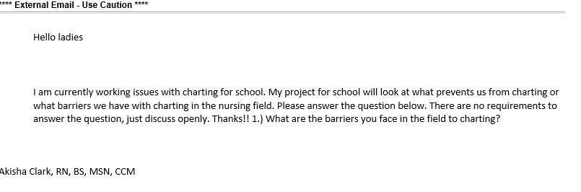

Appendix B

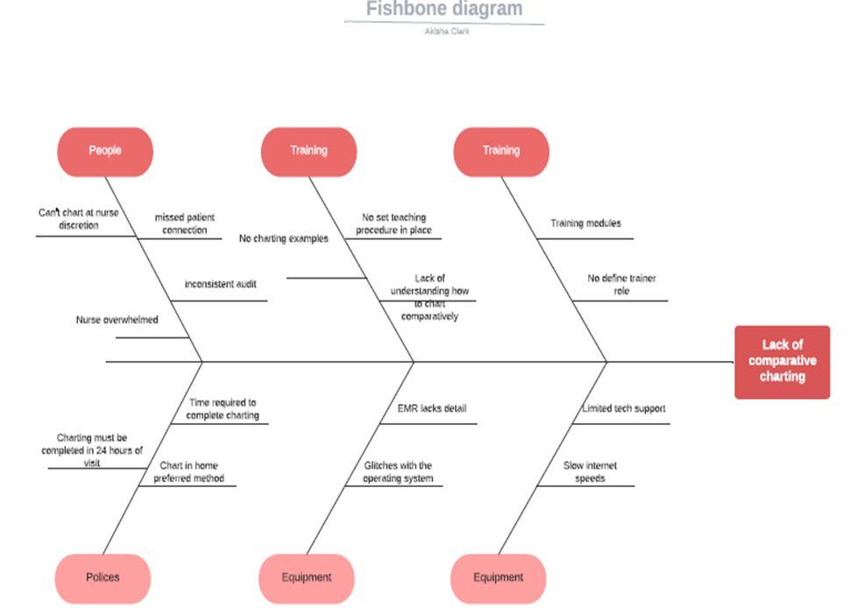

Appendix C

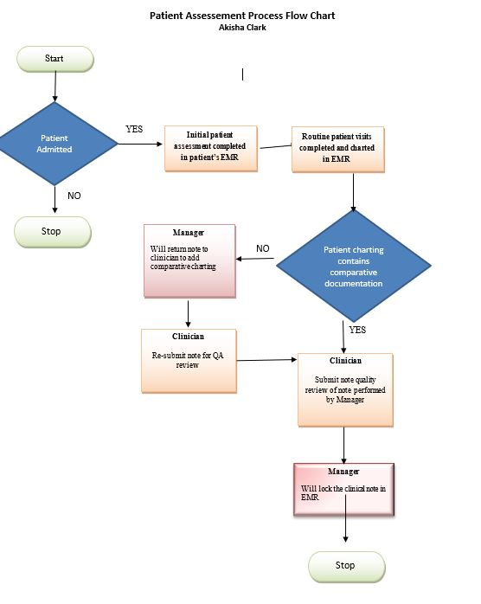

Appendix D

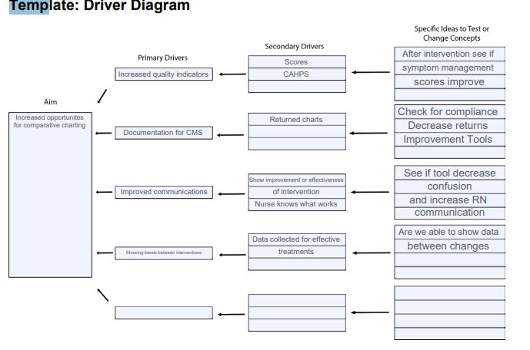

Appendix E
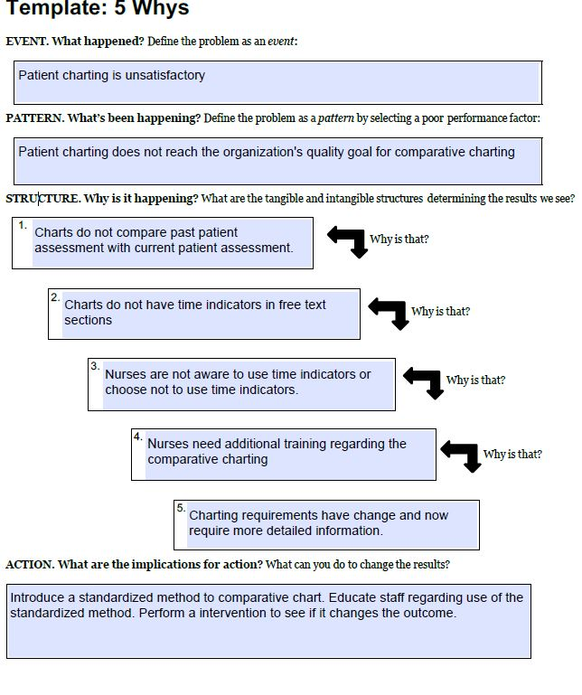

Appendix F
PDSA Cycle Template

Comparative Charting Intervention

QUALITY IMPROVEMENT TEAM MEMBERS

Akisha Clark, RN, MSN, Project Director | Key Leadership Stakeholder 201
Dr. Audris Smith | Key Leadership Stakeholder 202
Clinical Care Manager- Hospice 302 | Staff Nurse 102
Staff Nurse 101 | Staff Nurse 103
 | Staff Nurse 104
 | Staff Nurse 105

Outcome Report Date: August 24, 2021 Plan of Action Date: 6/03/2021

Target 1: Improvement in Clinical Documentation
Action Plan: Remediation
Goals:
1). By July 3rd, 2021, 30% of clinical documentation reviewed will evidence comparative charting in note “free text” sections of Kinnser
2). By July 3rd, 2021. Project director will have reviewed a total of 56 patient charts in Kinnser to determine if use of a comparative charting tool is effective for the organization.
Intense review will occur x4 weeks starting the week of TBD Intensity of review will be modified based on compliance to outlined goals. Akisha will analyze data and compile the results for reporting

Target Outcome addressed by Plan of Action: What is our Target Outcome?
Staff education will occur during the June 2021 staff meeting regarding quality improvement project and comparative charting

Identified Problem: Current clinical note review revealed a lack of assessment charting of differences in patient presentation, measurable progress towards goals, and specificity in patient interventions.

Care Behaviors or Processes Selected as Best Practices, committee to identify the best practice and plan.
POC development will be patient-centered and individualized based on the assessed care needs of the patient across disciplines
Intervention Actions: How are we going to fix with timelines is below in the chart.

- Educate/re-educate clinical staff on use of comparative charting tool during assessment.
- Intense review will occur x 4 weeks to measure compliance. Modifications to plan and review intensity will be adjusted based on results.

Action | Time Frame |  | Responsible  Person(s) | Monitoring Approaches  (and Frequency)
 | Start | Finish
1. Educate/re-educate staff on the use of comparative charting tool. | 6/3/21 | 6/3/21 | CCM, Project Director | Education to be completed on 6/03/21 with Zoom sessions for all participating nursing team members.
2. Intense review will occur x 4 weeks to measure compliance. Modifications to plan and review intensity will be adjusted based on results. | 6/3/21 | 7/3/21 | Project Director | Weekly data collection starting TBD with submission of data to project director for analysis.
- Evaluation:
- Review of Plan: End of Intervention Review
Responsible person(s): QA /Educator; CCM; Project Director
- Monitoring Activities: Clinical record reviews x 4 weeks to correct problem.
Date Completed: Plan July 3, 2021
Response: Successful intervention, 33% increase in comparative charting in free text areas

Respectfully submitted,
Akisha Clark, Doctoral Candidate

Appendix G
Comparative Charting Tool
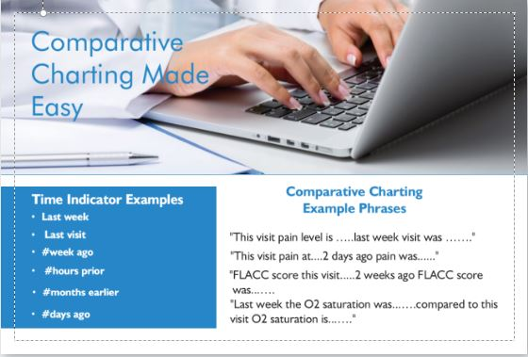

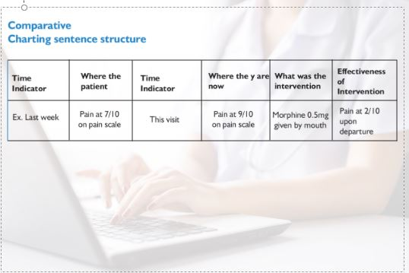

Appendix H
Chart Audit tool
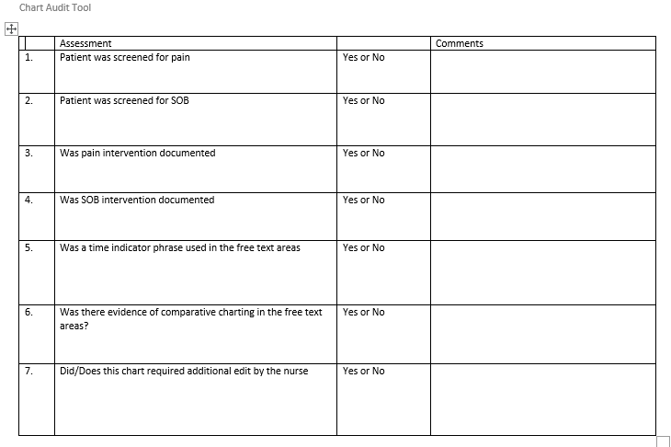

Appendix I
Pre-Survey/Post Survey
- I feel charting reduces the amount of time I have for patient care
  - Never
  - Rarely
  - Sometimes
  - Often
  - Always
- I complete my charting for the visit in the patient’s home
  - Never
  - Rarely
  - Sometimes
  - Often
  - Always
- I can easily see “visit to visit” changes in the patient condition in the patient’s chart
  - Never
  - Rarely
  - Sometimes
  - Often
  - Always
- I chart the patient’s pain intervention effectiveness and SOB intervention effectiveness
  - Never
  - Rarely
  - Sometimes
  - Often
  - Always
- I know what is expected in my charting
  - Never
  - Rarely
  - Sometimes
  - Often
  - Always

Appendix J
Hospice CAHPS Pain & Symptoms Measures (CMS, 2020)
Help for Pain and Symptoms | Global Measures
1) Did your family member get as much help with pain as he or she needed | 1) Using any number from 0 to 10, where 0 is the worst hospice care possible and 10 is the best hospice care possible, what number would you use to rate your family member’s care.
2) How often did your family member get the help she or he needed for troubled breathing? | 2) Would you recommend this hospice to your friends and family?

