Battling A Parallel Pandemic: An Evaluation of Sustainable System-Level Nursing Support in Response To COVID-19

Sara Gifford

University of Detroit Mercy

**Abstract**

**Key Words:** COVID-19, nursing, wellness, support, retention

**Purpose:**The COVID-19 pandemic has created many unique challenges for frontline nurses including psychological distress, trauma, and uncertainty. COVID-19 has also created equally challenging situations for healthcare systems as leaders look to combat high rates of nursing burnout and turnover throughout the pandemic. The purpose of this program evaluation is to evaluate a midwestern health system’s innovative *Resiliency Rounder Program*(Appendix A) and its effectiveness in supporting nurse well-being and retention during the COVID-19 pandemic.

**Methods:**The *Resiliency Rounder* *Program*evaluation utilized the Logic Model and Maslow's Hierarchy of Needs as guiding frameworks (Barkman, 2000; McLeod, 2020). Program evaluation data was collected through a mixed-methods approach. Key measures considered whether there were significant differences in nurse well-being and intent to leave current roles, the organization, and/or the profession between nurses who had an interaction with a “Resiliency Rounder” compared to those who did not.

**Results:**The *Resiliency Rounder Program* was effective in promoting system-level retention among inpatient and procedural nurses. Well-being scores were also significantly higher among nurses who worked on dedicated COVID-19 units, likely due to the fact that various support interventions were targeted towards these units. Despite higher wellness scores, dedicated COVID-19 nurses were found to be at greater risk of leaving not only current roles and the system related to COVID-19, but also the nursing profession. Costs related to the program were less than estimated COVID-19 turnover costs therefore showing that the *Resiliency Rounder Program* should be not only maintained, but also potentially expanded.

**Conclusion:**The *Resiliency Rounder Program* was effective in supporting nurse well-being and in decreasing intent to leave the organization during the COVID-19 pandemic. As the nursing workforce reaches the end of the COVID-19 crisis, healthcare systems must continue to explore systems’ roles in preparing for future workforce crises. Project conclusions will add to a growing body of knowledge regarding the COVID-19 pandemic and nursing support within the workplace, while also contributing to future implications for clinical practice and system-level improvements.

**Introduction**

*A simple but universal truth is that there can be no health without a workforce.*

*-World Health Organization, 2014*

The World Health Organization kicked off the year 2020 by declaring it the “Year of the Nurse” (World Health Organization, 2019). Simultaneously, the novel coronavirus (COVID-19) began infiltrating the global population leading to perhaps the largest pandemic of the modern world. Nurses sprang into action to combat the pandemic and began working around the clock to care for the millions of COVID-19 patients. As the most commonly infected healthcare personnel, many nurses became sick themselves while others continued to worry about bringing the virus home to family due to high rates of asymptomatic transmission in healthcare workers (Gómez-Ochoa et al., 2020). Personal protection equipment (PPE) suddenly became scarce resulting in nurses having to reuse supplies as hospitals scrambled to find masks, gloves, and gowns for staff. Despite unknown and continuously evolving conditions, nurses remained a constant at the bedside for the sick, scared, and lonely.

Although nurses have quickly become recognized as “heroes,” they have struggled to keep up with the mental, physical, and emotional demands of the pandemic (Appendix B). Prior to the pandemic, the number of professional nurses was barely keeping pace with population growth and the coronavirus emergency has only exacerbated the imbalance by putting further stress on the existing health workforce (Araujo & Garcia-Meza, 2020). Healthcare systems that have been heavily impacted by COVID-19 have been challenged with continuing to provide high-quality healthcare in addition to simultaneously battling these workforce problems. During an initial COVID-19 outbreak within the United States, St. Joseph Mercy Health System, a major healthcare organization serving southeast Michigan, quickly realized the impact of COVID-19 on frontline caregivers and created colleague support programs to aid the system’s workforce.

**Background**

As the largest healthcare profession, the nursing workforce is equipped to combat the current and future crisis of the nation’s health, yet the growing demand for nurses is at odds with the current supply. Almost one quarter of all hospitals currently report a nursing vacancy of 10% or greater (Snavely, 2016). By 2030, millions of registered nurses (RN’s) are expected to retire due to 50.9% of the nursing workforce being over 50 years old. At the same time, it is estimated that hundreds of thousands of nurses will be needed due to the growing patient population (American Association of Colleges of Nursing, 2019). Additionally, about 17.5% of new registered nurses, or nearly one in five new nurses, leave nursing jobs within the first year of work related to stressful work environments, verbal/physical abuse, dissatisfaction, and burnout (Robert Wood Johnson Foundation, 2013). When nurses stay within bedside roles, many report feelings of disengagement. Prior to COVID-19, fifteen of every one hundred nurses were considered disengaged according to the Press Ganey National Database of Nursing Quality Indicators (Dempsey & Reilly, 2016).

Healthcare leaders, such as those from the National Academy of Medicine, have sounded the alarms about a “parallel pandemic” within the healthcare workforce due to exposure to the virus in addition to pervasive and deleterious effects of the work environment on their mental health (Dzau et al., 2020). Research shows that infectious disease outbreaks cause frontline caregiver psychological distress manifested through various symptoms and conditions, such as sleep disturbances, traumatic stress, depression, and anxiety (Shechter et al., 2020; Lai et al., 2020; Kang et al., 2020; Lee et al., 2018; Su et al., 2007; McAlonan et al., 2007; Wu et al., 2009). In addition, levels of compassion fatigue, burnout, and disengagement among the nursing workforce have already been considered to be at a crisis level (Kelly, 2020). The harm from compassion fatigue, burnout, and secondary trauma in health care professionals is profound, impacting a significant portion of the workforce and manifesting in depression, emotional trauma, and suicide (Kelly, 2020).

During the United States’ initial COVID-19 surge, the American Medical Association recommended that health organizations act upon five requests from healthcare professionals—"hear me,” “protect me,” “prepare me,” “support me,” and “care for me” (Shanafelt et al., 2020). Building on the requests of “hear me,” “support me,” and “care for me,” St. Joseph Mercy Health System deployed colleague volunteers to begin rounding in high-stress unit environments. To “hear” staff, the program deployed leaders and other colleagues to gain expert perspective and understand concerns from frontline healthcare professionals within COVID-19 units. To “support” and “care” for staff, unit rounders engaged in conversations with the frontline staff members and delivered “Resilience Cards” during these check-ins. The “Resilience Cards” provided information on various St. Joe’s resources, such as the Employee Assistance Program, the Spiritual Care Department, the Trinity Health Community Resource Directory, and the St. Joe’s “Remarkable Resilience” website. As a branch of the Colleague Care Program, the *Resiliency Rounder Program* (Appendix A) was formalized to support frontline COVID-19 colleagues through real-time human connection.

**Significance of the Problem**

The nursing workforce has a tremendous impact on the cost of healthcare. Estimates suggest that a disengaged nurse costs an organization $22,200 in lost revenue as a result of lack of productivity, such as failure to offer assistance, performing work with a less-than-optimal attitude, calling in sick, and taking longer to complete routine tasks (Dempsey & Reilly, 2016). Nurse disengagement also influences turnover, resulting in annual system costs estimated at $3.6M to $6.1M (NSI Nursing Solutions Inc., 2020). In addition to costs, increased nurse turnover decreases patient access, patient safety, and quality of care while also affecting the engagement of remaining nurses by increasing their workload and job stress, ultimately leading to a cycle of burnout, disengagement, and further turnover (Press Ganey, 2015).

A growing body of evidence shows that insufficient nurse staffing can increase mortality rates, hospital-acquired infection rates, and readmission rates (Aiken et al., 2011; McHugh et al., 2013; Cimiotti et al., 2012; Haegdorens et al., 2019; Mitchell et al., 2018). High patient-to-nurse ratios, or decreased staffing levels, are associated with increased hospital-acquired infections such as surgical site infections and catheter-associated urinary tract infections (Cimiotti et al., 2012; Mitchell et al., 2018). When there are more nurses with fewer patients, there is also a decrease in the odds of both patient deaths and failure-to-rescues (Aiken et al., 2011; Haegdorens et al., 2019).

Poor patient outcomes associated with nursing care also contributes to excess healthcare expenses (McHugh et al., 2013; Scott, 2009; Lavizzo-Mourey, 2013; Snavely, 2016). Healthcare facilities with inadequate nursing staffing levels are positively correlated with readmission rates showing that nursing care begins to translate into overall healthcare costs (McHugh et al., 2013). Unnecessary readmission rates and associated costs are approximately $26 billion for Medicare patients alone as reported by the Center for Medicare & Medicaid Services (Lavizzo-Mourey, 2013). Surgical site infections cost an organization between $10,443 to $25,546 per infection and $589 to $759 per catheter-associated urinary tract infection (Scott, 2009; Snavely, 2016). In addition to these infections, other healthcare-associated infections, such as ventilator-associated pneumonia and central-line-associated bloodstream infections, directly cost the U.S. healthcare system between $28.4 and $33.8 billion annually (Scott, 2009; Snavely, 2016).

Chronic nursing vacancies can extend beyond the hospital and result in distressing effects on local, regional, and national outcomes (Snavely, 2016). Nursing workforce shortages can result in a loss of tax revenue and decreased public funding for other projects such as infrastructure, education, and medical needs for the population (Snavely, 2016). For example, the state of Florida is forecasting a $226 million loss in revenue through 2025 as a direct result of the projected nursing shortage (Florida Center for Nursing, 2013; Snavely, 2016). Nursing shortages can also result in higher insurance premiums and healthcare cost sharing. Managed care organizations experience an increase of nearly one percent in hospital inpatient costs for every one percent increase in the nursing shortage (Roberts, 2009). At the state level, it was found that high nurse to population ratios were significantly associated with improved state health outcomes (Bigbee, 2008). On the global level, the United States overall nurse-to-population ratio has decreased since 2000, falling further below the median value when compared to other developed countries such as Australia, Switzerland, and Germany (Anderson et al., 2019). United States healthcare spending, however, is twice as high as any other developed country (Anderson et al., 2019). Outcomes such as life expectancy, chronic disease prevalence, hospitalizations from preventable causes, and avoidable deaths remain worse than other developed countries (Tikkanen & Abrams, 2020).

**Problem Statement**

The COVID-19 pandemic has magnified current workforce problems as well as the stressors of the healthcare environment. Trauma-related distress, compassion fatigue, and burnout are well-documented problems within nursing literature yet little has been done at the system or policy level to support the nursing profession in these areas. Intervention has historically been focused on personal responsibility for psychological health and well-being with an overemphasis on nurses being “resilient” in the face of under-staffing and intense emotional work (Maben & Bridges, 2020). Feelings of burnout, psychological distress, compassion fatigue, and secondary trauma exacerbated by the COVID-19 pandemic place nurses at a greater risk of reduced wellness and exiting bedside patient care roles.

Hospitals, units, and nursing teams within the southeastern Michigan (SEMI) region of St. Joseph Mercy Health System have been faced with staffing challenges during the COVID-19 pandemic. Nursing managers, executive leadership, and organizational development professionals have identified nursing burnout and turnover as major concerns for the regional system. In response to these challenges and the literature calling for system-level support, Trinity Health requested that St. Joseph Mercy Health System enhance the *Resiliency Rounder Program* to combat colleague distress and turnover. In collaboration with the Chief Nursing Officer, the Chief Human Resources Officer, and the Senior Consultant for Organization Design and Development, targeted outcome measures were identified and explored to evaluate the *Resiliency Rounder Program’s* effectiveness in improving nurse well-being and retention throughout the COVID-19 pandemic.

**Clinical Questions**

What are the effects of the COVID-19 pandemic on nursing workforce well-being? Can a system level program improve nursing wellness and retention?

**Literature Review**

CINAHL, PubMed/MEDLINE, and Proquest Health & Medicine Databases were searched to access various resources related to the wellness and support of the nursing workforce. Multiple search terms such as “nursing wellness,” “nursing support,” “nurse engagement,” “secondary trauma,” “moral distress,” “burnout,” “compassion fatigue,” and “pandemic nursing” were used to identify the literature. Recently published resources were the focus for supportive literature, and relevant literature on historical pandemics was included as well. Although other healthcare workforces can contribute to this analysis, resources that did not include the nursing workforce were excluded. The following main concepts were identified in the review.

**Infectious Disease Outbreaks and Psychological Distress**

Research shows that infectious disease outbreaks cause frontline caregiver psychological distress manifested through various symptoms and conditions, such as sleep disturbances, traumatic stress, depression, and anxiety (Shechter et al., 2020; Lai et al., 2020; Kang et al., 2020; Lee et al., 2018; Su et al., 2007; McAlonan et al., 2007; Wu et al., 2009). In particular, nurses are at an increased risk for psychological distress when compared to other healthcare workers perhaps due to their increased time spent delivering direct patient care (Shechter et al., 2020; Kang et al., 2020; Lai et al., 2020).

Psychological distress can be related to a number of factors that occur due to an infectious disease outbreak. One major factor is that healthcare workers are at high-risk of contracting the new, unknown infectious agent. For example, during the severe acute respiratory syndrome (SARS) outbreak, healthcare workers had a higher rate of severe SARS infection than any other group with more than 20% of all SARS infections being healthcare workers (Wu et al., 2009). During the 2014-2016 Ebola outbreak, healthcare workers were between twenty-one to thirty-two times more likely to be infected with Ebola than people in the general population (World Health Organization, 2016). Healthcare workers are at an increased risk for not only acquiring the infection, but also potentially transmitting infection to patients, co-workers, and family/friends (Shechter et al., 2020). Healthcare workers have to worry about maintaining social distance from others, with about three in every four healthcare workers reporting high feelings of distress due to the fear of transmitting the infectious agent to family or friends (Shechter et al., 2020). In addition to increased risk of infection and transmission, a pandemic can also cause healthcare professionals to begin contemplating the risk of their own mortality. For example, during the Ebola crisis, the case fatality rate for healthcare professionals had been reported up to 73% (Suwantarat & Apisarnthanarak, 2015).

Along with stress related to infection, transmission, and mortality, healthcare workers often have to take on additional job responsibilities or new roles during infectious disease outbreaks. Due to surges, hospitals frequently have to reconfigure clinical spaces and redeploy many healthcare workers to areas outside their usual clinical specialty and/or expertise (Shechter et al., 2020). Staffing levels are often reported to be inadequate as novel infectious agents result in severely-ill patients and a need for specialized healthcare professionals over an extended period of time (Grimm, 2020). Increases in patient volume and work intensity coupled by the continuous accommodation of new protocols can also contribute to increased work stressors (Maben & Bridges, 2020).

While it has been claimed that the psychological distress occurs only during the immediate timeframe of the pandemic, multiple studies have shown that symptoms can last for an extended period of time. In a study examining healthcare workers’ psychological health during the SARS outbreak, a one-year follow-up showed that perceived posttraumatic stress scores increased in high-risk workers, resulting in chronic stress, depression, and anxiety (McAlonan et al., 2007). The scores of the high-risk group were also compared to scores of a low-risk group of healthcare workers (no contact with the SARS virus), showing that it was unlikely that elevated stress was attributable to the general caregiver role. Another study conducted during the SARS outbreak resulted in similar findings. Healthcare workers who had worked in high-risk locations were two to three times more likely to have high posttraumatic stress symptom levels with 40% of healthcare workers having persistent symptoms during the three years following the initial SARS outbreak (Wu et al., 2009). Similarly, a study examining healthcare workers throughout the Middle East respiratory syndrome (MERS) pandemic found that the group that performed MERS-related care had significantly higher psychological distress scores during the acute infection phase and six weeks later (Lee et al., 2018).

**Trauma, Compassion Fatigue, and Burnout**

Throughout COVID-19, media outlets have called the healthcare workforce “heroes” and have compared hospital units to “battlegrounds.” Trauma-related moral distress, compassion fatigue, and burnout are well-documented phenomena within military nursing. In military nursing, exposure to trauma, death, violence, threats to personal safety, and ethical dilemmas in austere work environments means that military nurses are at risk for psychological effects capable of impacting their personal and professional lives (Chargualaf & Elliott, 2019). Short- and long-term responses to these exposures manifest as depression, anxiety, stress, and moral distress that results in burnout, compassion, fatigue, post-traumatic stress, and post-traumatic stress disorder (Chargualaf & Elliott, 2019).

Similar to war-time nursing, novel infectious disease outbreaks present extreme patient care challenges. Watching patients die alone, constant worry about inadequate resources, and concern about one’s own health are all deeply distressing and unprecedented experiences for civilian healthcare workers that cannot be described as anything other than trauma (Kiser & Bernacki, 2020). In a study conducted in New York, more than half of healthcare workers caring for COVID-19 have screened positive for acute stress (post-traumatic stress disorder, or PTSD, symptoms within 1 month of trauma), almost half screened positive for depression, and one-third screened positive for anxiety (Shechter et al., 2020). The study also found that nurses are particularly affected by this trauma exposure likely due to having to provide 24/7 direct social support or emotional labor for patients and families (Shechter et al., 2020). Although PTSD-like symptoms are anticipated during trauma and some symptoms are expected to decline for many who initially screen positive for acute stress, a substantial proportion of nurses are likely to meet diagnostic criteria for PTSD beyond initial outbreaks (Shechter et al., 2020). Nursing during an infectious disease pandemic presents a situation of chronic traumatization. Within chronic traumas, longer periods of exposure have been associated with increased PTSD symptomatology (Kaysen et al., 2003).

As civilian nurse reports of burnout, compassion fatigue, and traumatic stress continue to increase, the effects of workplace trauma has resulted in the review of the “second victim experience.” The impact of an emotionally devastating clinical event on healthcare providers is known as the second victim experience where in the event’s aftermath the second victim experiences intense emotions and vulnerability (Scott, 2015). Many second victims believe they have failed the patient and the lasting emotional aftershock can alter or even end their healthcare career (Scott, 2015). Although the second victim has largely been studied in relation to medical errors, another emerging term in healthcare workforce literature is “secondary trauma.” Secondary trauma can be thought of as an occupational hazard and risk to knowing and caring for individuals, thus leading to compassion fatigue and burnout (Kelly, 2020). With varying definitions, causes, and rates, the incidence and prevalence of compassion fatigue and burnout have been difficult to pinpoint; however, conclusions remain that the levels of compassion fatigue and burnout related to secondary trauma among the nursing workforce is at that of a crisis level (Kelly, 2020). The harm from compassion fatigue, burnout, and secondary trauma in health care professionals can be profound, impacting a significant portion of the workforce and manifesting in depression, emotional trauma, and suicide (Kelly, 2020).

Even though trauma-related distress, compassion fatigue, and burnout have been proven to be prevalent among nurses, intervention has only been focused on personal responsibility for psychological health and well-being with an overemphasis on nurses being “resilient” in the face of under-staffing and intense emotional work (Maben & Bridges, 2020). Additionally, nurses report feeling worried or ignored when they raise concerns about their mental health (Maben & Bridges, 2020). Even among military nurses, a population that is expected to have trauma-related burnout, compassion fatigue, or persistent stress, there is reluctance to even identify or admit to these feelings over fears about how these symptoms will be perceived by others in the unit, including unit leaders (Chargualaf & Elliott, 2019).

**The Unknown – Something New for Modern American Healthcare**

The United States healthcare system attracts global talent and praise for its specialization, unlimited resources, technology, and up-to-date evidence. Despite many criticisms of the system, the United States has continued to be a leader in health innovation and care delivery with healthcare systems bringing in billions of dollars each year. For the first time in modern American history, however, the system has completely collapsed as it has struggled with dealing with the unknown. Despite patient census surging during COVID-19, thousands of healthcare workers have been furloughed and/or laid off (Paavola, 2020). For the staff that has remained within the four walls of the pandemic, the unknown has taken over daily work. Qualitative reports have shown that sources of distress related to the unknown during COVID-19 have included changing access to PPE, lack of organizational support, being unable to provide competent medical care, and limited up-to-date information and communication (Shechter et al., 2020). In addition, about 70% of healthcare workers reported uncertainty, or a lack of control, as a major cause of overall psychological distress (Shechter et al., 2020). Hospital administrators have also recognized the unknown as a major source of psychological distress for healthcare staff. In a March 2020 national survey of hospitals and healthcare leaders, hospital administrators expressed concern that fear and uncertainty were taking an emotional toll on staff, both professionally and personally (Grimm, 2020).

Fear of the unknown and psychological distress have been documented in literature related to major disasters, such as the terrorist attacks of 9/11, and disaster nursing. It has been shown that perceived risk levels related to an event are affected by the unfamiliarity and perceived uncontrollability of the hazards involved, and that these perceptions in turn affect a person’s likelihood for developing PTSD (Wu et al., 2009). Within disaster nursing, feelings of unpreparedness result in decreased self-confidence and concern over the ability to contribute to the healthcare team in a meaningful way (Chargualaf & Elliott, 2019). Rivers’ (2016) study on military nursing showed that functioning in a state of chaos, characterized by many unknowns and circumstances where military nurses have to “make do,” was overwhelming and left nurses with substantial emotional sequelae. Nursing during COVID-19 in America has been a scenario where nurses have felt that they have had to “make do” with the unknown, and will have to continue to “make do” with the unknown for the foreseeable future.

**Organizational Assessment**

An analysis of strengths, weaknesses, opportunities, and threats (SWOT) was performed on St. Joseph Mercy Health System. The goal of the SWOT analysis was to identify areas and processes that can be improved to better support services for staff members, particularly nurses, within the context of the current pandemic. Additionally, costs related to the organization’s *Resiliency Rounder Program* were evaluated in comparison to the cost of turnover and disengagement.

**Overview**

St. Joseph Mercy Health System (SJMHS) of southeastern Michigan (SEMI) includes five hospitals that are licensed for over 1,500 beds and currently employ 4,366 registered nurses (St. Joseph Mercy Health System, n.d.). After Michigan’s initial COVID-19 surge in March-April 2020, St. Joseph Mercy Health System saw an increase in vacant nursing positions (402 vacancies in October 2020) compared to the prior year (238 vacancies in October 2019). While some of these vacancies can be attributed to newly created positions, many nursing managers and system leaders have reported increased turnover, low levels of morale within nursing units, and worry that more nurses will leave the bedside. For example, St. Joseph Mercy Oakland’s Intensive Care Unit (ICU), a unit heavily impacted by COVID-19, has seen a post-surge turnover rate of 13%. Eight out of sixty nurses have recently left the unit due to external travel contracts, advanced roles or continuing education, and other nursing roles within the system. While the unit looks to fill those eight positions, leadership is also challenged with filling 16 new nursing positions that have been created to staff the new COVID-19 unit housed within the ICU. Staffing the hospital’s new COVID-19 unit in addition to the normal critical care census has placed tremendous stress on the nursing staff, especially after the COVID-19 surge.

**Strengths**

***Peer Culture***

Many staff members say that feelings of teamwork and resilience define the nursing staff. Throughout the initial surge of coronavirus, there was a Facebook group called “St. Joe’s Strong” that was made up of various St. Joe’s staff members and was dedicated to positive thoughts and motivation. There is a strong willingness to heal, care, and improve patient outcomes and experiences.

***Nursing Education/Advancement***

There are structured nursing-driven practice councils that represent the nursing practice throughout each hospital site. There are also centralized nursing support teams that extend into the various hospital units. Nursing practice advancement is a part of the organizational culture.

***Current Support Programs***

The organization offers services for colleague support through the *Colleague Care Program* and an Employee Assistance Program (EAP). The system also developed the *Resiliency Rounder Program* to focus on hospital- and unit-based rounding for frontline healthcare workers.

**Weaknesses**

***Staffing Imbalance***

While many specialty nurses floated into high-volume areas during the COVID-19 surge, specialty nurses have gone back to their home units, such as the operating room, the cardiac catheterization lab, etc., as the number of procedures returned to normal. This has resulted in staffing shortages on various units. Staffing imbalances can completely disrupt any improvement efforts and lead to feelings of burnout related to increased job demands.

***Burnout***

Staff members report feeling overwhelmed, overtired, and morally distressed after COVID-19. Nurses are dealing with the aftermath of the COVID-19 surge while simultaneously struggling with return of regular patient census numbers and low staffing numbers.

**Opportunities**

***Hospital-Based Colleague Support***

There is an opportunity to strengthen hospital-based colleague support programs, such as the *Resiliency Rounder Program* based on stakeholder requests. With the support of stakeholders, there is an opportunity to evaluate it for effectiveness and feasibility.

***Developing Research***

Many health systems and research centers (such as the Institute for Healthcare Improvement) have begun exploring colleague support programs as a result of the coronavirus pandemic and the emotional toll it has taken on caregivers. There will continue to be an abundance of research and programs coming out in response to the “parallel pandemic.”

**Threats**

***COVID-19 Resurgence***

As colleague support looks to be improved, all healthcare systems and hospitals must be ready for future COVID-19 surges. Another surge could completely uproot any kind of research or process improvement projects while also taking an additional toll on staff members who are already distressed.

***Resource Restructuring***

Due to the financial impact of COVID-19, many organizations find themselves reallocating resources, personnel, and budgets. Restructuring resources can pose a threat to current processes and programs.

**Costs**

Since the *Resiliency* *Rounder Program* began with colleagues volunteering to fill rounder roles, program costs are mainly related to time. Throughout SEMI, there are about sixty-five *Rounders* in total. *Rounders* are current colleagues in all levels of the organization (human resources, social work, behavioral health, spiritual care, executive leaders) that round on units in addition to their usual job responsibilities. The following is a table that estimates the cost of the *Rounders* in addition to other program expenses.

|  |  |  |  |  |  |
| --- | --- | --- | --- | --- | --- |
| Program Expense | Cost | Amount | Time | Estimated Monthly Total | Estimated Annual Totals |
| Resiliency Rounders* | $47-68/hr | 65 colleagues | 3 hours per week  (12 hours per month, 156 hours per year) | $36,660-$53,040 | $476,580-$689,520 |
| Colleague Support Cards | $0.05 | 4366 (1 card per RN) | N/A | $18 | $218 |
| Facilitating Personnel* | $62/hr | 3 colleagues | 8 hours per week  (32 hours per month, 416 hours per year) | $5,952 | $77,376 |
| Employee Assistance Program* | $12-$40 per RN | 4366 RN’s | 1 year | $364-14,553 | $4,366-$174,640 |
| Overall Total: | | | | $42,994-$73,563 | $558,540-$941,754 |

Table 1.1: *Resiliency Rounder Program* Expenses (*pre-existing system resource)

Overall *Resiliency Rounder Program* costs are estimated to be between $558,540 and $941,754 annually; however, it is important to note that some of the costs can be attributed to pre-existing system resources such as the contracted Employee Assistance Program and personnel that are current colleagues/leaders.

In comparison to the cost of nursing turnover and disengagement, the *Resiliency Rounder Program* is significantly less costly. According to a national survey by NSI Solutions, the average cost of turnover for a bedside RN is $44,400 and ranges from $33,300 to $56,000 resulting in the average hospital losing $3.6m – $6.1 million annually (2020). Costs of turnover include termination costs (such as payment for unused paid-time off), costs of unfilled vacant positions (overtime payment or hiring of temporary agency nurses), advertising and recruiting costs, new staff hiring costs, and new staff training (Robert Wood Johnson Foundation, n.d.). The following is a table that estimates the cost of St. Joseph Mercy Health System’s nursing vacancies.

|  |  |  |  |
| --- | --- | --- | --- |
|  | October 2019 | October 2020 | Differences |
| Number of Nursing Vacancies* | 238 | 402 | +164 |
| Costs of Turnover | $33,300-$56,000 | $33,300-$56,000 | N/A |
| Total | $7,925,400-$13,328,000 | $13,386,600-$22,512,000 | +$5,461,200-$9,184,000 |

Table 1.2: Costs of Nursing Vacancies (*some vacancies attributed to newly created positions)

While new RN positions have recently been created within St. Joseph Mercy Health System, there is still a substantial difference in the number of nursing vacancies between October 2019 and October 2020. This could be due to a number of factors, but surely the COVID-19 pandemic and its effects on the frontline caregiver workforce cannot be ignored. The 164 additional nursing vacancies account for estimated costs of about $5.4-9.1 million for the system, whereas the overall total of the *Resiliency Rounder Program* (much of which is funded using pre-existing system resources) is less than $1 million. These costs show that sustainability, feasibility, and growth of the *Resiliency Rounder Program* can be justified from a financial perspective.

**Theoretical Framework**

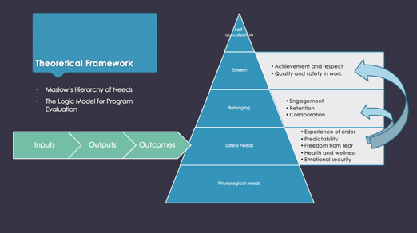 Maslow’s Hierarchy of Needs will serve as a guiding theory throughout the project. Maslow’s Hierarchy of Needs is a motivational theory in psychology comprising a five-tier model of human needs with needs lower down the hierarchy needing to be satisfied before individuals can attend to higher up needs (McLeod, 2020). From the bottom of the hierarchy upwards, the needs are physiological, safety, belonging, esteem, and self-actualization (McLeod, 2020).

Figure 1.1: Theoretical Framework (Maslow’s Hierarchy of Needs and The Logic Model)

Maslow's Hierarchy can easily be applied to nurses in the workplace during COVID-19. For example, during the peak surges, many workplaces partnered with local restaurants and hotels to supply meals and shelter for frontline healthcare workers so that they did not have to worry about meeting their basic needs during the pandemic. After these physiological needs, safety needs must be met to work towards belonging and esteem needs, which can align with common workplace goals of engagement and retention. In other words, if nurses do not reach a level of safety at work then they would be unable to advance to levels of belonging and esteem. According to Maslow, safety needs include the experience of order, predictability, freedom from fear, health, wellness, and emotional security (McLeod, 2020). During COVID-19, many nurses have felt “unsafe” related to uncertainties, fear of catching the disease and/or bringing it home, emotional/psychological distress, etc. Without the proper intervention, these feelings have and will continue to prevent nurses from reaching a level of belonging and esteem within their workplace and profession.

The Logic Model for Program Design and Evaluation will also be used as a framework to guide the project. The Logic Model can help bring detail to “broad, fuzzy goals” by helping to focus the evaluation and monitor the program’s progress as well as needed changes (Barkman, 2000). Inputs, outputs, and outcomes are explored in the table below (Barkman, 2000).

|  |  |  |  |  |  |
| --- | --- | --- | --- | --- | --- |
| Inputs | Outputs | | Outcomes-Impact | | |
|  | Activities | Participation | Learning | Action | Impact |
| Resilience Rounders  Colleague Care Team administration  Support resources (EAP, etc.)  Resiliency Rounder resource cards | Rounding  Coordination among hospitals, central administration  Creation of central SharePoint website | Nurses  Resiliency Rounders  Program Administrative Personnel | Improved feelings of “resiliency”  Improved awareness of organizational support | Improved well-being scores  Decreased intent to leave organization | Improved colleague wellness  Decreased turnover/ vacancies  Financial savings |

Table 2.1: The Logic Model applied for the *Resiliency Rounder Program*

The following are assumptions related to the program:

1. If colleagues connect with a *Resiliency Rounder*, they will have an improved awareness of organizational support.
2. If colleagues are aware of organizational support resources, they will have higher well-being scores.
3. If colleagues have higher well-being scores, they will have decreased intentions to leave the organization.

**Purpose Statement and Objectives**

The COVID-19 pandemic created many unique challenges for frontline nurses including psychological distress, trauma, and uncertainty. COVID-19 also created equally challenging situations for healthcare systems, especially as leaders looked to combat high rates of nursing burnout and turnover throughout the pandemic. Innovative colleague support programs emerged to support the nursing workforce and nursing wellness resulting in the need to evaluate these programs for effectiveness and sustainability. The purpose of the program evaluation was to:

1. Evaluate St. Joseph Mercy’s system-level *Resiliency Rounder Program* to determine whether the program is effective in supporting nurse well-being and in decreasing intent to leave current roles, the organization, and/or the nursing profession related to the COVID-19 pandemic.

Project objectives were to:

1. Describe *Resiliency Rounder* perceptions towards the program’s structure, process, and outcomes.
2. Measure data related to nurse well-being and intentions to stay and/or leave the unit, organization, and profession in relation to participation in the *Resiliency Rounder Program.*
3. Recommend opportunities for improvement to the program based on findings, outcomes, financial implications, and stakeholder interests.

**Implementation Plan**

**Project Design**

The project evaluated the *Resiliency Rounder Program* utilizing a mixed-methods approach.

***Phase One (September 2020-January 2021)***

The first phase of the scholarly project included studying the intervention, identifying targeted outcomes, and planning for implementation of evaluation measures. This phase mainly consisted of meetings and communications with the *Resiliency Rounder Program* personnel and stakeholders. Results of phase one were a quantitative survey based on the program’s purpose and stakeholder interests as well as a qualitative survey aimed at identifying themes related to the program’s structure, processes, and outcomes.

The first part of the project design included an anonymous quantitative survey. A SurveyMonkey® internet survey was built using a combination of about 25 relevant questions from proven tools, such as the “Well-Being Index” and the organization’s colleague engagement survey (Mayo Clinic, 2018). Additionally, questions that the investigators and stakeholders agree were valuable to the project, such as questions related to current employer-provided resource utilization, were also included. The survey was composed of three parts: general questions, wellness questions, and workplace questions (Appendix C). The investigator began promoting the survey at system nursing leadership meetings in December 2020 and January 2021. These meetings were attended by the regional Chief Nursing Officers and various nursing directors. Based on feedback at these meetings the survey was promoted among nursing managers and clinical leaders at each hospital within the health system.

The second part of the project design included planning for interviews with the *Resiliency Rounders*. Based on feedback from stakeholders and *Resiliency Rounder* Check-Ins (meetings), a qualitative interview framework was drafted to aid in identifying themes. The investigator began promoting interview participation through email messages and announcements at the January 2021 and February 2021 *Resiliency Rounder* Check-Ins.

The scholarly project was reviewed and approved by the Institutional Review Board (IRB) committees at St. Joseph Mercy Health System and University of Detroit Mercy prior to implementation. University of Detroit Mercy approved the project on January 26th, 2021 after the St. Joseph Mercy Health System research committee approved the project on January 11th, 2021.

***Phase Two (February 2021-March 2021)***

The second phase included implementation of the outcome evaluation plan during February and March 2021. A survey link was sent out via email to system nurses by the investigator, senior nursing leadership, and nurse managers. Additionally, a Quick Response (QR) code that linked to the survey site was created and passed out during *Resiliency Rounding*. The QR code was also posted around inpatient units and promoted to nursing administration staff members (managers, assistant managers, etc.). For the qualitative piece of the project, *Resiliency Rounders* volunteer participantsmet individually with the investigator for 15+ minute interviews. These interviews were promoted during *Resiliency Rounder* Check-Ins and scheduled during February and March 2021.

***Phase Three (April 2021-May 2021)***

Phase three was designated for data analysis, including continued financial analysis of the program. Quantitative data analysis utilized the Statistical Package for the Social Sciences® (SSPS®) program. Demographic characteristics of the nurses, COVID-19 roles, and resource utilization were explored using descriptive statistics. To examine whether there was a significant difference in well-being between nurses who have had contact with a *Resiliency Rounder* and those who have not, the research question was analyzed using an independent t-test. The same test was utilized to examine whether there was a significant difference with intent to leave current roles, the organization, and the profession in nurses who have had contact with a *Resiliency Rounder* and those who have not. Lastly, qualitative data from the *Resiliency Rounder* individual interviews was transcribed and coded. The content was reviewed among a three-member team to determine meaningful themes, and/or concepts.

***Phase Four (May 2021 – August 2021)***

The final phase of the scholarly project includes finalizing recommendations and a sustainability plan for the health system. Stakeholder meetings will occur to discuss the project findings and recommendations within the context of the National Academy of Medicine’s *Taking Action Against Clinician Burnout: A Systems Approach to Professional Well-Being* series’ six recommended domains or organizational evidence-based practices that support well-being (Sinsky et al., 2020).

**Setting and Sample**

St. Joseph Mercy Health System (SJMHS) of southeastern Michigan (SEMI) currently employs about 4,366 registered nurses across the system. The SurveyMonkey® survey was emailed out to all inpatient unit-based and procedural nurses throughout St. Joseph Mercy’s SEMI region. Procedural nurses were included in the survey since many were redeployed to inpatient COVID-19 units during the initial surge. The survey was promoted at the hospital sites by administrative personnel and the investigator, as well as through email communications. About 373 nurses (8.5%) accessed and responded to the survey.

For the qualitative data collection, eight interviews with *Resiliency Rounders* were conducted. *Resiliency Rounders* included St. Joseph Mercy Colleagues that worked in departments such as nursing leadership, spiritual care, behavioral health support, etc. Interviews occurred virtually.

**Ethical Considerations**

The risk of harm to human subjects was expected to be minimal. Informed consent was obtained prior to survey and interview participation. Surveys were completed anonymously and interview participants were not identified during recording. IRB approval was obtained through St. Joseph Mercy Health System and the University of Detroit Mercy prior to data collection.

**Evaluation Methods**

**Outcome Measures**

The project measured quantitative outcomes through a SurveyMonkey® survey. The survey included a combination of about 25 questions regarding demographics, well-being, roles during COVID-19, colleague assistance resources, and retention. To measure *Resiliency Rounder Program* effectiveness, the project explored nurse well-being and intent to leave a unit, the organization, or the nursing profession (retention). The project compared differences in well-being and retention scores of nurses who had contact with a *Resiliency Rounder* compared to those who did not.

While the project’s complete evaluation gathered data/information about all components of the program, including qualitative data from the *Resiliency Rounders*, the stakeholders and the investigator felt that well-being and retention outcomes were most valuable for measuring overall effectiveness of the program. To build on effectiveness, the survey also asked questions that the investigators and stakeholders agreed were valuable to the sustainability of the project. Additional data helped to explain findings, highlighted the most and/or least effective pieces of the program, identified at-risk nursing groups, and displayed any relevant secondary outcomes.

The project also evaluated the program through individual qualitative interviews with the *Resiliency Rounders*. The qualitative interview (Appendix D) utilized Donabedian’s organizing concepts of structure, process, and outcome, which remain central to measuring and improving quality (Berwick & Fox, 2016). Examples of questions related to structure and process included, “How much time do you think should be allotted for *Resiliency Rounding?*” and “What specific resources do you think nurses need during the COVID-19 pandemic?”. The interview also evaluated outcomes through questions such as “How have you seen the *Resiliency Rounder Program* positively impact nurses?” and “How has the *Resiliency Rounder Program* experience impacted you as a *Rounder*?”.

Lastly, costs of the program were evaluated in relation to key findings. *Resiliency Rounder Program* costs were compared to the cost of the number of nurses with intent to leave the organization and estimated vacancy rates based on retention results (see Table 3.1 and Table 3.2 in “Results”).

**Data Collection Tools**

One of the main objectives of the project was to measure nurse well-being. This measurement utilized the Well-Being Index. The Nurse Well-Being Index is a validated screening tool to evaluate fatigue, depression, burnout, anxiety/stress, and mental/physical quality of life (Mayo Clinic, 2018). The tool contains seven Yes/No questions, one 7-point Likert scale question, and one 5-point Likert scale question. The index was developed through a rigorous process with multi-step validation in >18,000 working US adults including both health care workers and the general US population (Mayo Clinic, 2018). Evidence shows that the tool is valid for identifying nurses in distress (i.e. low overall quality of life, burnout, extreme fatigue, recent suicidal ideation) and for identifying those whose degree of distress places them at risk for adverse professional consequences, such as intent to leave their current job and/or patient care errors (Dyrbye et al., 2018). At the organizational level, Well-Being Index scores by demographic characteristics such as years in nursing, work unit, and shift, could help organizations seeking to improve nurse well-being optimize resource allocation and focus efforts to the area of greatest need (Dyrbye et al., 2018). The Well-Being Index is scored based on the 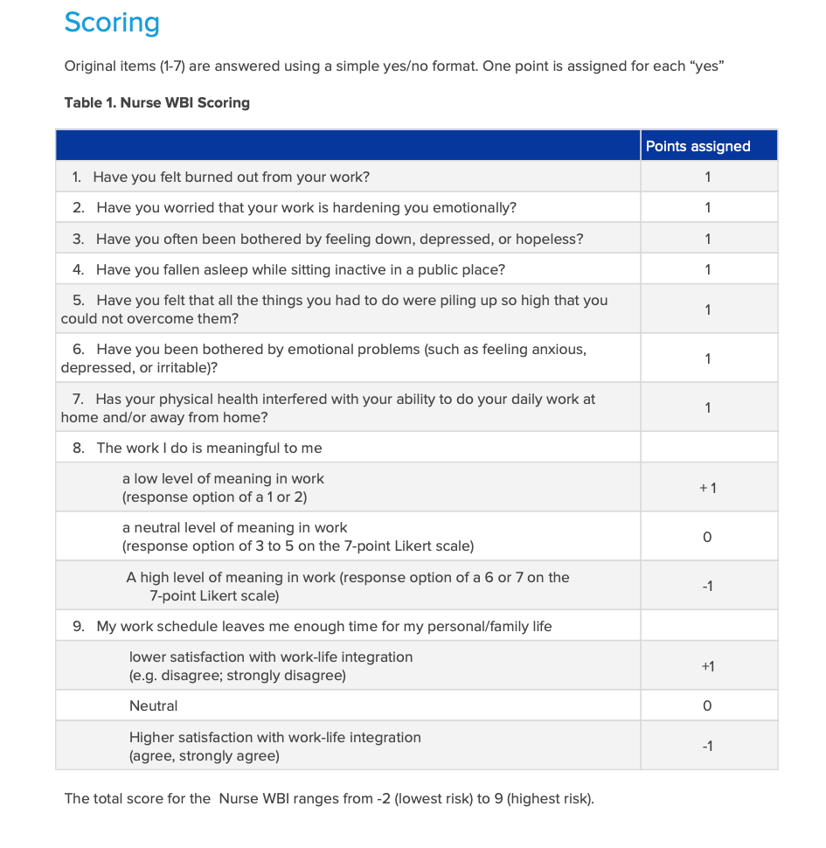listed below.

Figure 2.2: Nurse Well-Being Index Scoring (Well-Being Index, n.d.)

In addition to the Well-Being Index, questions related to intent to leave current units/roles, the system, and or the profession were adapted from the system’s Safe and Reliable Healthcare SCORE annual engagement survey. According to Safe and Reliable Healthcare, SCORE is the most outcomes-predictive and validated integrated survey in healthcare, with full Tier-1 Leapfrog and Magnet/ANCC accreditation (2020). Questions were pulled and tailored from the “job-related uncertainty” and “ intentions to leave” sections to include the relevance of COVID-19 in relation to retention and engagement. These decisions and alterations were agreed upon by the project team and stakeholders.

**Data Analysis**

Quantitative data analysis utilized the SSPS® program. Demographic characteristics of the nurses, COVID-19 roles, and resource utilization were explored using descriptive statistics. To examine the main project objectives of determining whether there is a significant difference in well-being between nurses who have had contact with a *Resiliency Rounder* (individual, group, or both) and those who have not, Well-Being Index results were total/scored for each respondent and analyzed through N-Way Analysis of Variance (ANOVA) statistical tests with Bonferroni post-hoc analyses. Since there were no significant differences in the post-hoc analyses, *Resiliency Rounder* contact was recoded to “any contact” and “no contact.” The research question was analyzed using an independent t-test. The same test was utilized to examine whether there was a significant difference with intent to leave current roles, the organization, and the profession in nurses who have had contact with a *Resiliency Rounder* and those who have not. Retention data was measured on a 6-point Likert scale from Strongly Disagree (0) to Strongly Agree (5). Responses were coded as either Disagree (0-3) or Agree (4-6). Lastly, qualitative data from the *Resiliency Rounder* individual interviews were transcribed and coded. The content was reviewed among a three-member team to determine meaningful themes, and/or concepts.

**Results**

A detailed list of results, graphs, and analyses can be found in Appendix E (pages 55-79). The following sections will provide a brief summary of findings.

**Demographics**

About 373 nurses accessed and responded to the quantitative survey. Majority of the respondents were nurses with 0-10 years of experience. Many of the nurses stated they worked on medical-surgical units or in “other” environments (not critical care, emergency department, float pool, or surgical/procedural) and almost 250 ( about 70%) of the survey respondents stated that they worked day shift.

While over 250 nurses identified they had directly cared for COVID-19 patients during the pandemic, a majority of the nurses were not working on units that were fully converted to COVID-19 units. Additionally, 253 of the nurses (75%) claimed that they had not had contact with a *Resiliency Rounder* compared to the 76 nurses (23%) who did have contact with a *Resiliency Rounder*.

**Well-Being Index Scores**

Well-Being Index scores were totaled and analyzed. Scores ranged from -2 (lowest risk) to 9 (highest risk). “At-risk” scores are defined as greater than or equal to 2 for nurses (Well-Being Index, n.d.). Based on overall system scores, about 69% of St. Joseph Mercy nurses are considered to have “at-risk” wellness scores. When compared to a national sample of US workers (N=3238), the national sample mean was 2.32 (2.63) while St. Joe’s mean score (N=335) was 2.6209 (1.92747) (Well-Being Index, n.d.). The mean score and percentage of “at-risk” nurses are slightly higher than the national average. Well-Being Index Score data was also analyzed for each hospital site.

**Retention Scores**

About 30% of nurses felt they were considering leaving their current unit/role due to COVID-19. Additionally, 23% of nurses felt that they were considering leaving the system and the profession because of the COVID-19 pandemic.

**Main Findings**

The purpose of the project was to evaluate St. Joseph Mercy’s system-level *Resiliency Rounder Program* to determine whether the program is effective in supporting nurse well-being and in decreasing intent to leave current roles, the organization, and/or the nursing profession related to the COVID-19 pandemic. The first research question explored whether there was a difference in well-being scores between nurses who had contact with a *Resiliency Rounder* compared to those who did not. Although nurses who had contact with a *Resiliency Rounder* had lower (better) Well-Being Index Scores, there was not a significant difference (t=-2.433, p=.918) in Well-Being Index Scores between those who had contact with a *Resiliency Rounder* (2.1579 ± 1.91174)compared to those who have not (2.7668 ± 1.91407).

The second research question explored whether there was a difference in intent to leave current units/roles, the health system, and/or the profession between nurses who had contact with a *Resiliency Rounder* compared to those who did not. This question was broken down into three separate questions for data collection. It was found that there was not a significant difference (t=-0.366, p=.451) in nurses intending to leave current units/roles due to COVID-19 between those who had contact with a *Resiliency Rounder* (1.29 ± 0.456)compared to those who have not (0.464 ± 0.033). Additionally, there was not a significant difference (t=-0.729, p=.128) in nurses intending to leave the profession due to COVID-19 between those who had contact with a *Resiliency Rounder* (1.20 ± 0.403)compared to those who have not (1.25 ± 0.432). There was, however, a significant difference (t=-1.234, p=0.008) in nurses wanting to leave the St. Joe’s system due to COVID-19 between those who had contact with a *Resiliency Rounder* (1.18 ± 0.385)compared to those who have not (1.25 ± 0.436). Nurses who had contact with a *Resiliency Rounder* disagreed more that they were considering leaving the system due to COVID-19.

|  |  |
| --- | --- |
| Research Questions – Key Outcome Measures | Outcome |
| Was there a significant difference in Wellness Scores between nurses who had contact with a *Resiliency Rounder* compared to those who did not? | No |
| Was there a significant difference in intent to leave current units/roles between nurses who had contact with a *Resiliency Rounder* compared to those who did not? | No |
| Was there a significant difference in intent to leave the system between nurses who had contact with a *Resiliency Rounder* compared to those who did not? | Yes |
| Was there a significant difference in intent to leave the profession between nurses who had contact with a *Resiliency Rounder* compared to those who did not? | No |

Table 3.1: Results of key outcome measures.

To describe *Resiliency Rounder* perceptions towards the program, the following themes were identified in the qualitative interviews: *variability, value and appreciation, looking ahead, and connection and teamwork*. Interview results displayed variability in *Resiliency Rounder* roles and dedicated time to round. There were many comments about the future of the program and how it can continue to support the well-being of nursing staff while both complimenting other resumed rounding responsibilities and adapting to the new “normal” within the workplace. Overall, many of the *Rounders* felt the program made an impact and boosted morale among all colleagues by giving everyone a voice and a listening ear during a difficult time.

**Other Key Findings**

The main research questions were explored for differences between nurses who worked on fully converted COVID-19 units compared to those who did not. There was a significant difference (t=-4.654, p=0.044) in nurse Well-Being Index Scores between those who worked on a fully converted COVID unit (2.0248 ± 1.70520)compared to those who did not (3.0452 ± 1.95640). Nurses who worked on fully converted COVID units reported better Well-Being Index Scores than those who worked on non-COVID units or mixed units. While Well-Being Index scores were better, retention scores were not. There was a significant difference (t=3.755, p=0.000) in nurses’ intent to leave current roles/units between those who worked on a fully converted COVID unit (1.43 ± 0.497)compared to those who did not (1.21 ± 0.409). Nurses who worked on fully converted COVID units agreed more that they were considering leaving their current units/roles related to COVID-19. There was also a significant difference (t=3.676, p=0.000) in nurses’ intent to leave the system between those who worked on a fully converted COVID unit (1.34 ± 0.475)compared to those who did not (1.14 ± 0.346). Nurses who worked on fully converted COVID units agreed more that they were considering leaving the system related to COVID-19. Lastly, there was asignificant difference (t=4.285, p=0.000) in nurses’ intent to leave the profession between those who worked on the fully converted COVID units (1.35 ± 0.479)compared to those who did not (1.12 ± 0.323). Nurses who worked on fully converted COVID units agreed more that they were considering leaving the nursing profession related to COVID-19.

|  |  |
| --- | --- |
| Research Questions – COVID-19 Units | Outcome |
| Was there a significant difference in Wellness Scores between nurses who worked on fully converted COVID units compared to those who worked on non-COVID units (or mixed units)? | Yes |
| Was there a significant difference in intent to leave current units/roles between nurses who worked on fully converted COVID units compared to those who worked on non-COVID units (or mixed units)? | Yes |
| Was there a significant difference in intent to leave the system between nurses who worked on fully converted COVID units compared to those who worked on non-COVID units (or mixed units)? | Yes |
| Was there a significant difference in intent to leave the profession between nurses who worked on fully converted COVID units compared to those who worked on non-COVID units (or mixed units)? | Yes |

Table 3.2: Results of fully converted COVID-19 units.

**Financial Implications**

Costs of the program were compared to costs of nurses with intent to leave the system and vacancies. The following is a table that estimates the cost of the *Rounders* and other program expenses in comparison to the estimated number of nurses with intent to leave the system based on data findings. To calculate the estimated number of nurses with intent to leave the organization, the total number of system nurses (4366 RN’s) was multiplied by the percentage of nurses who expressed intent to leave the organization in the survey (23%). Based on this calculation and the average costs of turnover for a bedside RN by NSI Solutions ($33,300 to $56,000), the costs of the nursing turnover for the system is estimated to be significantly greater than the annual costs of the *Resiliency Rounder Program* (2020).

|  |  |  |  |  |
| --- | --- | --- | --- | --- |
| Expense | Number/Amount | Cost to System | Estimated Monthly Total | Estimated Annual Totals |
| Resiliency Rounders* | 65 colleagues | $47-68/hr x 3 hours per week | $36,660-$53,040 | $476,580-$689,520 |
| Colleague Support Cards | 4366 (1 card per RN) | $0.05 | $18 | $218 |
| Facilitating Personnel* | 3 colleagues | $62/hr x 8 hours per week | $5,952 | $77,376 |
| Employee Assistance Program* | 4366 RN’s | $12-$40 per RN x 1 year | $364-14,553 | $4,366-$174,640 |
| Overall Program Monthly Total | ----- | ------ | $42,994-$73,563 | $558,540-$941,754 |
| Nurses with Intent to Leave Organization | 1004 RN’s (23%) | 33,300-$56,000  (turnover costs) | ----- | $33,433,200-$56,224,000 |

Table 3.3: Evaluation of program costs compared to turnover costs in relation to findings.  
 Since inpatient and procedural nurses could not be differentiated from the total number of system RN’s, nursing vacancies were also explored for more specific cost comparisons. While the number of vacancies between October 2019 (pre-COVID) and October 2020 (during COVID) were previously compared, some of the October 2020 vacancies could be attributed to newly created nursing positions to help supplement staffing during the COVID crisis. To further estimate the number of vacancies related to turnover due to COVID-19, the percentage of nurses that expressed intent to leave the system in the survey (23%) was used to calculate the estimated number of vacancies related to COVID-19 retention from the pre-COVID baseline vacancy rate (238 vacancies). This resulted in an increase of 55 additional vacancies across the system, creating additional retention costs of about $1.8-$3 million for the system. In comparison to the annual costs of less than $1 million for the *Resiliency Rounder Program* (much of which is pre-existing system resources), the cost comparisons show that sustainability and potential growth of the *Resiliency Rounder Program* can be justified from a financial perspective.

|  |  |  |  |  |
| --- | --- | --- | --- | --- |
|  | October 2019 (Pre-COVID) | October 2020 (during COVID) | Data Findings/ Estimated vacancies related to COVID-19 retention (March 2021) | Estimated Costs of COVID-19 retention |
| Number of Nursing Vacancies | 238 | 402* | 293 (23% increase) | +55 more vacancies |
| Costs of Turnover | $33,300-$56,000 | $33,300-$56,000 | $33,300-$56,000 | ----- |
| Total | $7,925,400-$13,328,000 | $13,386,600-$22,512,000 | $9,756,900-$16,408,000 | +$1,831,500-$3,080,000 |

Table 3.4: Costs of Nursing Vacancies (*some vacancies attributed to newly created positions)

**Discussion**

The *Resiliency Rounder Program* was effective in supporting nurse well-being and decreasing intent to leave the organization during the COVID-19 pandemic. Aligning with the *Resiliency Rounder Program* qualitative themes of value, appreciation, connection, and teamwork, it was found that nurses who had contact with *Resiliency Rounders* reported significantly higher levels of intent to stay within the system. While the program did not lead to statistically significant higher well-being scores among nurses who had contact with *Rounders*, well-being scores were higher for those who had contact with *Rounders* compared to those who did not. Limitations to the program evaluation included low survey response rates and small sample sizes of nurses who had contacts with *Resiliency Rounders*. Majority of respondents did not have access to a *Resiliency Rounder*. Further exploration on the impact of the *Resiliency Rounder Program* on nursing wellness and retention should be explored.

Additionally, nurses who worked on fully converted COVID-19 units had higher well-being scores than those who worked on mixed units or non-COVID units. This is likely due to the fact that COVID units were heavily targeted for well-being interventions, such as *Resiliency Rounding*. Despite higher well-being scores, nurses who worked on fully converted COVID-19 units reported statistically significant increased intent to leave not only their roles and the system, but also the nursing profession. Aligning with the concerns about a “parallel pandemic” of psychological distress and a workforce exodus, nurses are showing that feelings of burnout, compassion fatigue, and secondary trauma have truly been so exacerbated by the COVID-19 pandemic that they want to leave the nursing profession altogether (Dzau et al., 2020). Healthcare systems and nursing leadership must recognize the new crisis at stake as well as the heavy emotional and physical work that dedicated COVID-19 nurses have taken on throughout the pandemic. Looking forward, future research and intervention must focus on workplace wellness initiatives that are innovative, flexible, and effective from the level of the individual nurse to system-level programming.

**Sustainability Plan**

The final objective of the project is to recommend opportunities for improvement to the program based on findings, outcomes, financial implications, and stakeholder interests. Building on the National Academy of Medicine’s *Taking Action Against Clinician Burnout: A Systems Approach to Professional Well-Being* series, the *Resiliency Rounder Program* sustainability plan is guided by six recommended domains of organizational evidence-based practices that support well-being (Sinsky et al., 2020).

**Domain 1: Organizational Commitment**

A systems-based commitment to workforce well-being and organizational resilience is essential for preventing burnout within an organization (Sinsky et al., 2020). Including measures of workforce well-being within the organization’s strategic plan can show a commitment (Sinsky et al., 2020). The commitment to workforce well-being aligns with St. Joseph Mercy Health System’s Core Value of Safety, or embracing a culture that prevents harm and nurtures a healing, safe environment for all (Trinity Health, 2020). The continuation of the *Resiliency Rounder Program* displays a commitment to well-being and safety. Refining colleague well-being initiatives within the strategic plan can be further explored as more data is gathered from colleagues through various initiatives, such as the system’s Safe and Reliable Healthcare SCORE annual engagement survey.

**Domain 2: Workforce Assessment**

It is not possible to know how an organization, or parts of an organization, are performing without accounting for well-being and burnout (Sinsky et al., 2020). While measurement of well-being can be considered a good starting point, it is important to build upon these results and further explore significant findings as well as other workplace factors known to have an impact on well-being. Results should be shared with stakeholders, leaders across the organization, and unit leaders that are responsible for addressing and improving the results (Sinsky et al., 2020). The results and recommendations of the *Resiliency Rounder* program evaluation were shared with various leaders and colleagues at the end of the project. Additionally, as previously stated in Domain 1, workforce assessments can be expanded through various initiatives and measures, such as the system’s engagement surveys. As nurses also continue to adjust to the “new normal,” their perceptions towards post-COVID wellness resources and support programs should be assessed to maximize impact and sustainability.   
**Domain 3: Leadership** By establishing shared accountability among an organization’s executive leadership team and distributed leadership among professionals closest to patients, an organization can structurally support a health work environment and achieve Quadruple Aim outcomes (better care, better health, lower cost, and better clinician experience) (Sinsky et al., 2020). Organizations can also strategically commit to building infrastructure to support workforce well-being through formal leadership positions, such as a Chief Wellness Officer, and/or progression of formal programs, such as the *Resiliency Rounder Program* (Sinsky et al., 2020). The *Resiliency Rounder Program* should not only be continued, but adapted to fit the changing needs of inpatient nurses and colleague *Rounders*. As workplace responsibilities continue to fluctuate and evolve beyond the COVID surges, it should be recognized that the flexibility needed for rounding can be difficult to balance with pre-existing workflows. Wellness and support initiatives should be assigned to a dedicated individual or team and separated from existing responsibilities to avoid time conflicts. If a dedicated individual or team cannot be financially supported, innovative and diverse colleague teams (paralleling hospital-based ethics committees) can be created for consultation during difficult situations or for nurses/units that need extra support.

**Domain 4: Policy** During the COVID-19 pandemic, many regulatory bodies, licensing and credentialing organizations, and healthcare systems have removed policy barriers to teamwork and efficiency. For example, nursing documentation within the electronic medical record (EMR) has been simplified to include only necessary components within the EMR’s “Disaster Mode.” Policies surrounding compliance and EMR documentation are time consuming when added in sum and lead to many frustrations for nurses (Sinsky et al., 2020). Before systems return to “business as usual,” organizations should reassess which policies and processes are necessary for high-quality patient care and which ones should be retired (Sinsky et al., 2020). While this domain may not be directly influenced by the *Resiliency Rounder Program*, it should be noted that workforce wellness may not significantly improve until policy barriers are addressed. This may have an effect on future outcomes of the *Resiliency Rounder Program* and should be considered in relation to sustainability. As part of improving nursing wellness and retention, nurses’ opinions and thoughts on workplace policies should continue to be heard throughout unit- and hospital-based councils.

**Domain 5: Efficiency of Work Environment**

Building on the policy domain, barriers to teamwork and efficiency must be reduced to also ensure operational efficiency of the work environment and clinical excellence. Many healthcare professionals go into healthcare to be able to listen carefully, assess, make clinical decisions, and build relationships with patients and colleagues (Sinsky et al., 2020). Yet many clinicians believe that administrative and technology focused tasks dominate their days resulting in logistical-style work that is often performed while distracted (Sinsky et al., 2020). As the work environment continues to evolve through innovative care models and practice changes, colleague well-being must be considered in the evaluation of these changes (Sinsky et al., 2020). While this domain may also not be directly influenced by the *Resiliency Rounder Program*, it is important to note that inefficient workflows can have an effect on well-being and the outcomes of the *Resiliency Rounder Program*. Similar to Domain 4, work environment should also be considered in relation to the *Resiliency Rounder Program’s* sustainability and effectiveness in improving wellness and retention.

**Domain 6: Support**

The primary means by which an organization supports its workforce is by giving them the ability to do their jobs and then allowing them to return safely home with energy to engage in their personal lives (Sinsky et al., 2020). Another important means of support is by creating a culture of connection at work, such as peer-to-peer discussions or colleague connections, which is what the *Resiliency Rounder Program* accomplishes through individual and group interactions. Aligning with Maslow’s Hierarchy of Needs, nurses must feel safe within the workplace before reaching levels of belonging and esteem, or in other words, engagement, retention, quality, and safety. Building on the *Resiliency Rounder Program,* additional formal support structures must be explored and recommended based on not only the findings of the evaluation, but also further exploration into nurses’ perceptions of colleague support beyond the COVID-19 crisis. “Opt out” programming instead of “opt in” programming should be considered as well as incentives or bonuses that are similar to the major sign-on bonuses that are often used for recruiting.

**Implications for Practice**

Given the national shortage of nurses and the costs associated with recruiting and training when a nurse leaves, there is both an ethical and business case to justify monitoring nurse well-being, taking action to promote wellness, supporting those in distress, and addressing system issues to create a culture of wellness (Dyrbye et al., 2018). Additionally, there is an ethical and business case to support nurses when considering the impact nursing care has on patient outcomes. While the Triple Aim—improving the patient experience of care, improving the health of populations, and reducing per capita costs—has spread to assist in the redesign of healthcare systems, organizations continue to struggle in meeting the framework’s intended outcomes. The positive engagement and well-being of healthcare professionals, particularly nurses, is of paramount importance in achieving the goals of the Triple Aim (Bodenheimer & Sinsky, 2014).

As the nursing workforce reaches the end of the COVID-19 pandemic, healthcare systems must continue to prioritize and respond to the *parallel pandemic* through the exploration of systems’ roles in preparing for future crises. By adopting a fourth point to the Triple Aim framework—clinician experience—healthcare systems can commit to the new “Quadruple Aim” through the prioritization of colleague well-being beyond the COVID-19 pandemic as a key strategy in the pursuit of Triple Aim outcomes. Through careful planning and evaluation of strategic goals, healthcare systems can have a major impact on nurse well-being and retention, as well as improved patient outcomes.

**Conclusion**

The *Resiliency Rounder Program* was effective in supporting nurse well-being and in decreasing intent to leave the organization during the COVID-19 pandemic. Value, teamwork, and connection aided in nurses feeling appreciated and contributed to their desire to stay within the system. Continued attention must be given to nurses who served on dedicated COVID-19 units throughout the pandemic as these nurses are at high risk of leaving the nursing profession. Practice improvements should focus on proven sustainability methods, such as the National Academy of Medicine’s *Taking Action Against Clinician Burnout: A Systems Approach to Professional Well-Being (*Sinsky et al., 2020)*.* Future research should continue to study the effects of the COVID-19 pandemic on the nursing workforce, as well as interventions that contribute to the well-being and retention of nurses beyond the crisis. As the COVID-19 pandemic slowly becomes more of a memory for the nation’s healthcare workers rather than the present reality, the lessons learned can help prepare for the next healthcare crisis. Systems must be prepared to support a fragile nursing workforce and maintain retention initiatives as key priorities in contributing to the nation’s health. Overall project findings add to a growing body of knowledge regarding the COVID-19 pandemic and nursing support within the workplace while also contributing to future implications for clinical practice and system-level improvements.

**Appendix A – *Resiliency Rounder Program* Description**

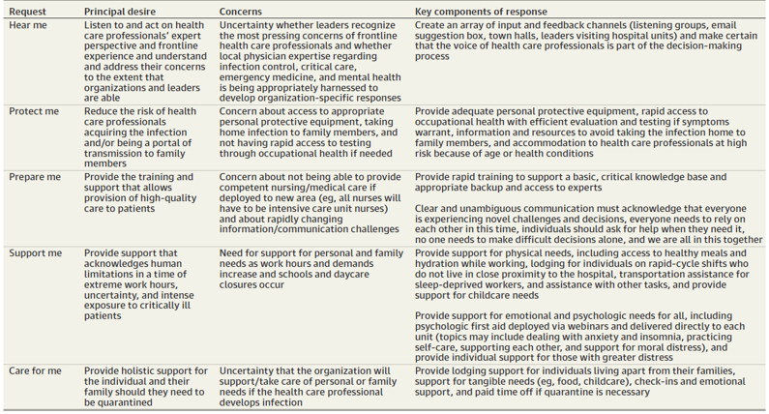 St. Joseph Mercy Health System, a member of Trinity Health, is a healthcare organization serving seven counties in southeast Michigan (St. Joseph Mercy Health System, n.d.). St. Joseph Mercy Health System’s combined five hospitals are licensed for 1,548 beds and employ more than 15,300 individuals (St. Joseph Mercy Health System, n.d.). In response to the COVID-19 pandemic, St. Joseph Mercy began a formalized colleague support program, the *Resiliency Rounder Program*, to assist with colleague wellness. Building on the American Medical Association’s support requests, the *Resiliency Rounder Program* focuses on the requests of *hear me, support me, and care for me* (Shanafelt et al., 2020). These requests are further explained in the following graph.

The main goal of *Resiliency Rounding* is to provide Trinity Health colleagues with real-time human connection that delivers purposeful active listening, gratitude, and empathy (Brokaw, 2020). Other goals of *Resiliency Rounding* are to:

* Be a connector to resources (i.e. Employee Assistance Program)
* Be an empathetic listener,​​
* Touch base with colleagues in high stress environments.​
* Express gratitude, ​
* Provide brief supportive messaging, ​
* Identify emerging issues within department units or amongst colleagues,
* And link colleagues to available resources, if desired (Brokaw, 2020).

Hospital-specific commitment to the program includes identified high-risk units, frequency in rounding, rounding times/shifts, rounding team members, and rounding methods (in-person vs. phone). Program commitments have evolved since the initiation of the program, with certain hospital sites adapting their associated team, methods, times, etc. and disseminating updates to the rest of the region through *Resiliency Rounder* update meetings.

Data collection methods currently include a centralized spreadsheet that is updated by each hospital site. Each site tracks their method or rounding, the number of interactions they have with colleagues, the number of unit huddles attended, and the type of department/unit rounded on. Beyond this, *Rounders* report informal, qualitative stories to show value and significance of the program.

**Appendix B – A COVID-19 Nurse’s Narrative**

*Dear World,*

# *A month’s time had passed in the blink of an eye. It just disappeared.*

*I work in New Orleans’ only level 1 trauma unit.  
  
We see so much in a days work.  
  
We deal with loss every day and we’ve dealt with it every day for a long time. We're pretty numb to the traumatic things we see; you find a way to compartmentalize it and prioritize care to save patients' lives.  
  
We get in there with every patient. Especially nurses. It’s a race against time, it’s an intimate experience. We get physically close to our patients.  
  
During the COVID-19 rollout, we didn't know what was going on yet, because this was all in the early stages. So the extra steps to protect ourselves became a really big obstacle to how we usually work. We’re usually in the rooms, next to the patient for long amounts of time.  
  
With COVID-19? The opposite.  
  
We stay in the rooms only as long as we absolutely need, to reduce exposure. I just remember the doctor saying, "This is your new normal folks." It felt very surreal, lonely, scary, an overwhelming feeling of the unknown.  
  
Walking into what is usually an already chaotic unit during the peak of COVID-19 was intense. Alarms, nurses yelling through doors and respirators and banging on doors from the inside asking for supplies, code carts lining the hallways, blue gowns everywhere. The rooms quickly changed from trauma patients to COVID-19 patients.  
  
Early in the stages of COVID-19, I met my sweet patient.  
  
Riddled with comorbidities and a pending COVID-19 test, she was a very kind and frail lady. She spoke so patiently to me and others she encountered throughout the day, even during a time of suffering for her.  
  
This day was her last and she was spoken to mostly through a glass door or by people garbed up in masks, respirators, gowns, and protective eyewear; she didn't even know what her caregivers looked like. How terrifying.  
  
Losing a patient is never easy, I want that to be understood. The nature of caring for trauma patients, though, has a way of hardening you.  
  
This day, the hardened shell I had built completely shattered and the tears were plentiful.  
  
Those around me commented, "What's wrong with you? We do this every day!" I felt the same way, but I couldn't control it.  
  
It took a few hours and a quick trip out into the fresh air to shake it off. I thought, "What is wrong with you, get it together!"  
  
This was a different feeling of loss; one I had never really experienced. She lived her last day without seeing her family; her family wasn't able to comfort her in her last hours in such an unknown and scary time in the world. That is all I could think of. I couldn't fathom losing a loved one this way.  
  
COVID-19 has made its way into our lives by stealing precious time from everyone — time from patients in their last hours, time from doctors, nurses, and respiratory therapists locked away from their families after caring for COVID-19 patients, time from family members worried about their loved ones as they battle this virus seemingly alone. A months' time had passed in the blink of an eye. It just disappeared.  
  
I've cared for so many patients before her and after her, but I've never cried like that over a patient.  
  
Sincerely,*

# *I’ve Never Cried Like That About A Patient1*

1A story written by Sarah Wells for the #DearNurses COVID-19 edition of “Dear World” (2020).

**Appendix C – Quantitative Survey Questions**

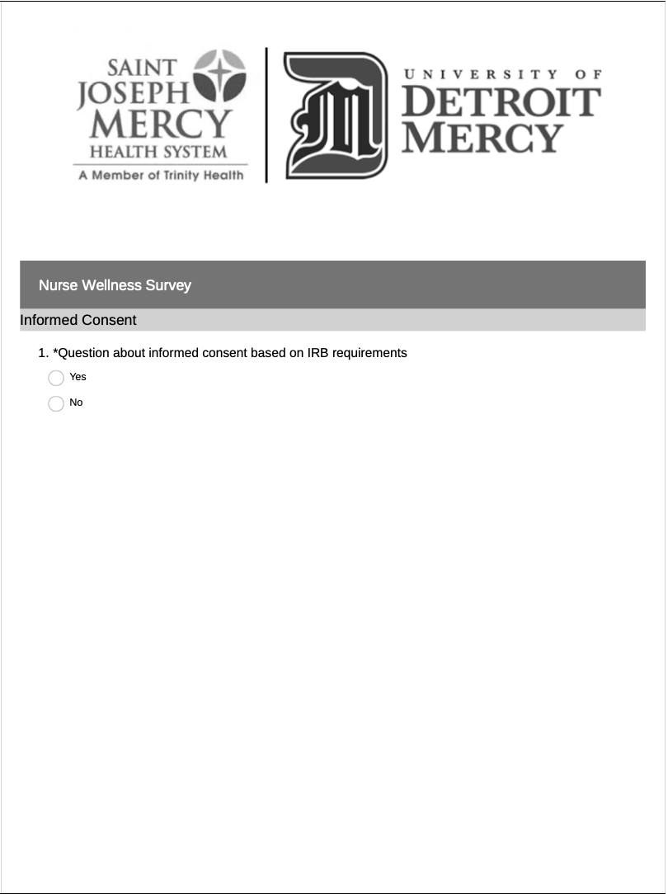

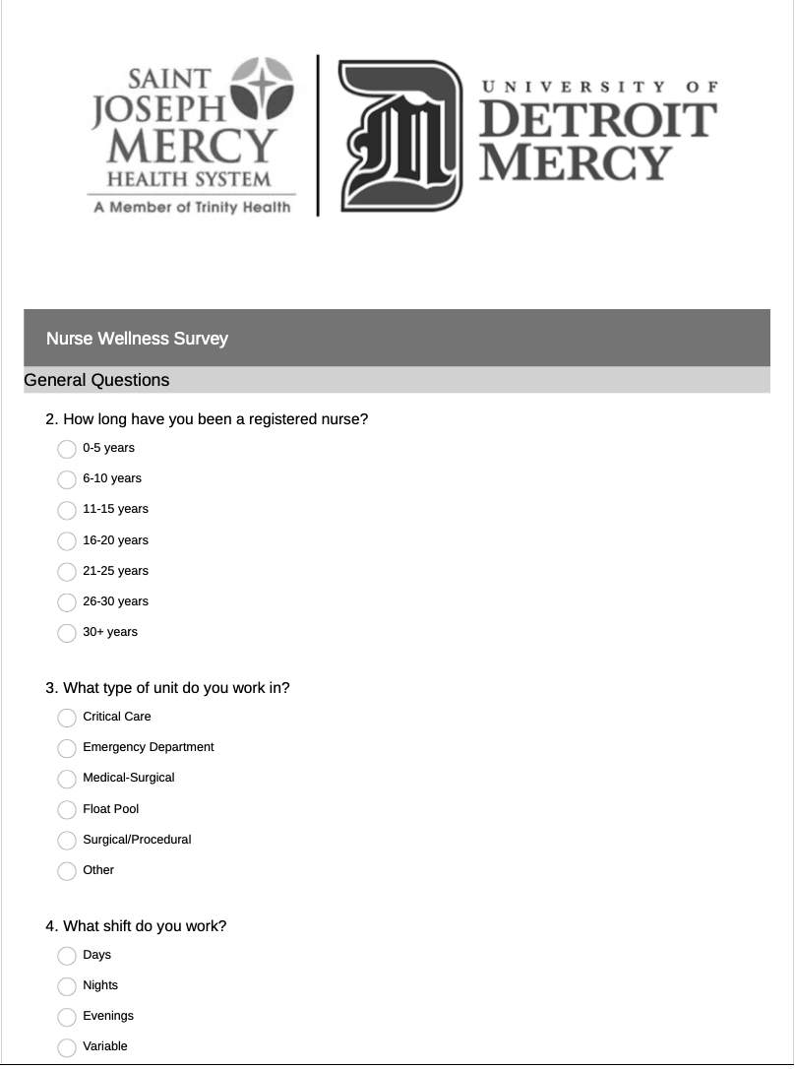

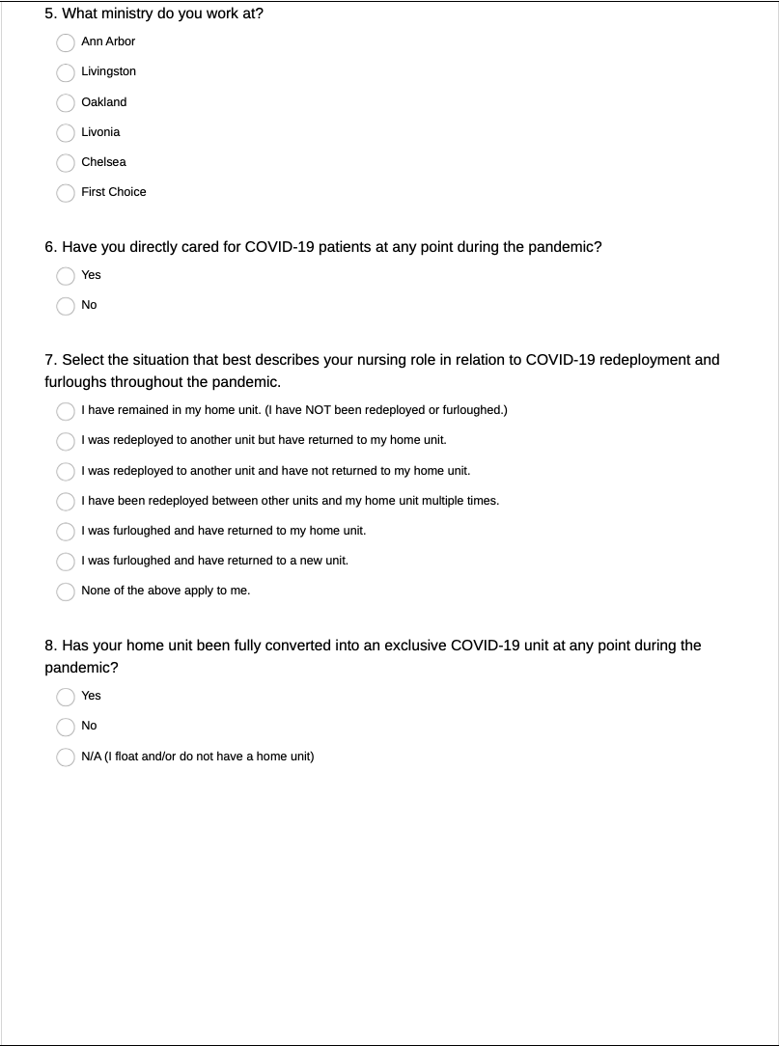

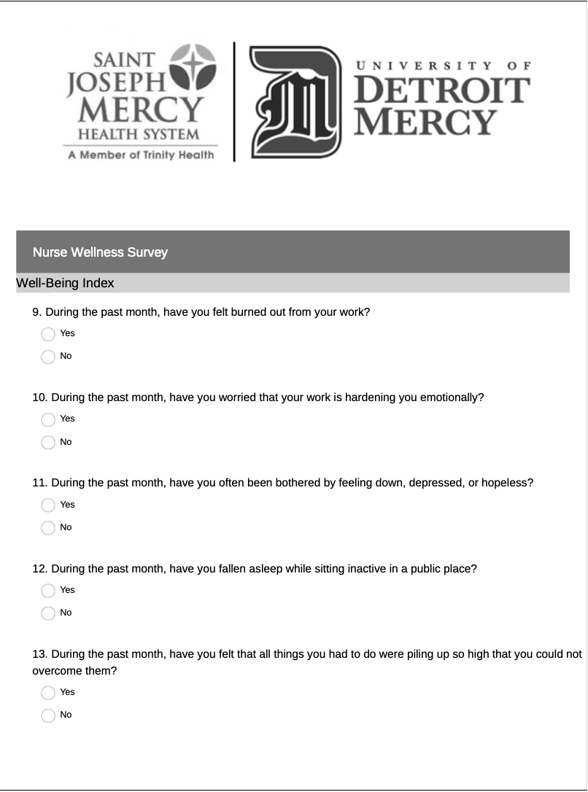

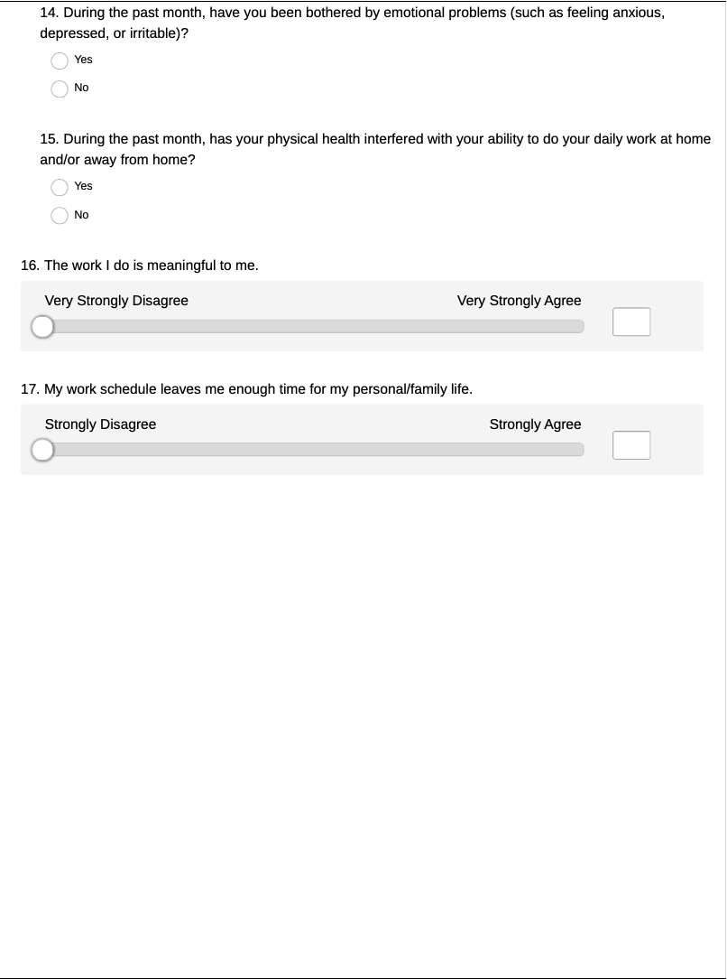

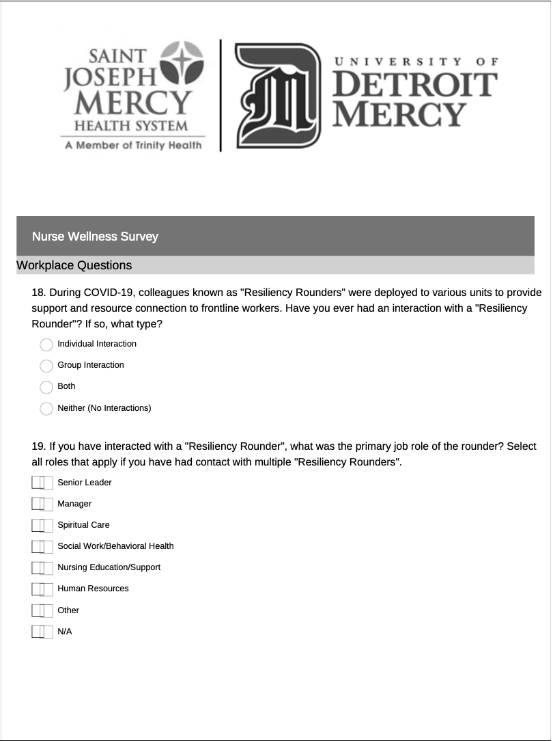

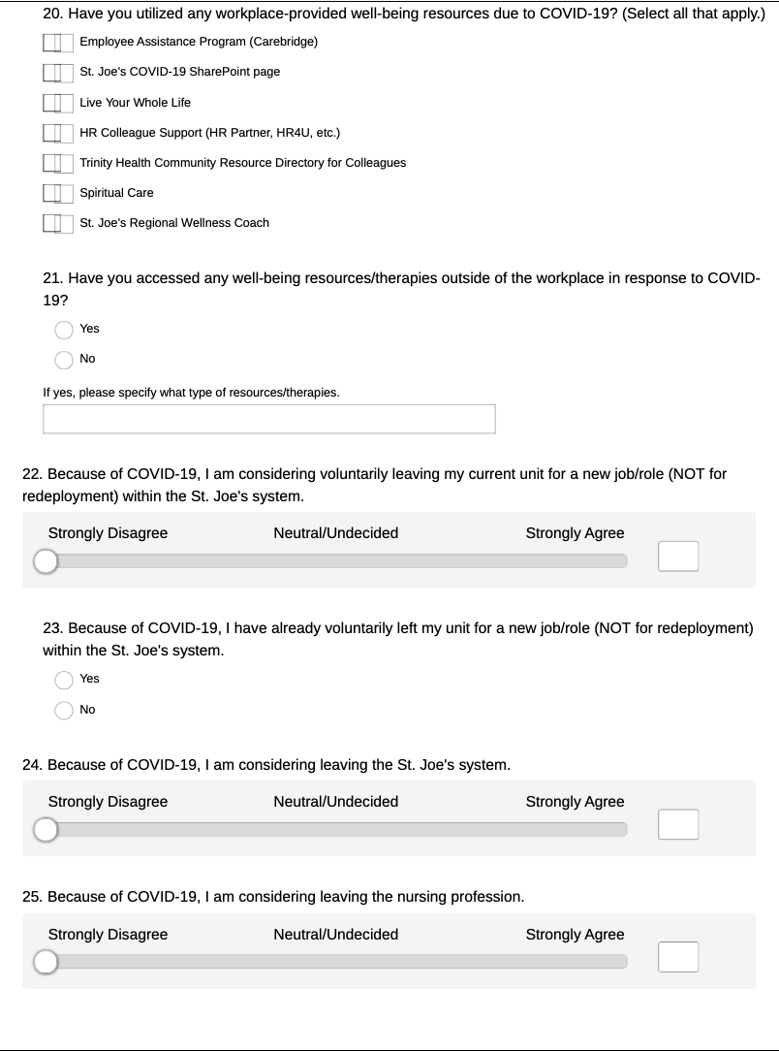

**Appendix D – Qualitative Interview Questions**



**Appendix E – Data Analysis and Results**

**RESILIENCY ROUNDER DATA ANALYSIS REPORT**

**DEMOGRAPHICS**

**Q2: How long have you been a registered nurse?**

**Q3: What type of unit do you work in?**

**Q4: What shift do you work?**

**Q5: What ministry (hospital site) do you work at?**



*First Choice is a Trinity Health internal staffing agency float pool that supplies nurses to Saint Joseph Mercy Health System hospitals.

**Q6: Have you directly cared for COVID-19 patients at any point during the pandemic?**

**Q7: Select the situation that best describes your nursing role in relation to COVID-19 redeployment and furloughs throughout the pandemic.**

**Q8: Has your home unit been fully converted into an exclusive COVID-19 unit at any point during the pandemic?**

**CODING AND ANALYSIS**

RESILIENCY ROUNDER INTERACTIONS

**Q18: During COVID-19, colleagues known as “Resiliency Rounders” were deployed to various units to provide support and resource connection to frontline workers. Have you ever had an interaction with a “Resiliency Rounder?” If so, what type?**

**\*Note: Due to sample size, data was recoded to “any rounding” and “no rounding” for all analyses.**

**CODING AND ANALYSIS**

WELL-BEING INDEX SCORES: SYSTEM AND HOSPITAL-SPECIFIC

**The total score for the Nurse WBI ranges from -2 (lowest risk) to 9 (highest risk). “At-risk” scores are defined as greater than or equal to 2 for US nurses.**

About 69% of system nurses are considered to have “at-risk” wellness scores.

|  |  |  |
| --- | --- | --- |
|  |  | Valid Percent |
| Valid | -2.00 | 0.3% |
| -1.00 | 3.9% |
| .00 | 11.3% |
| 1.00 | 14.9% |
| **2.00** | **18.2%** |
| **3.00** | **17.3%** |
| **4.00** | **13.7%** |
| **5.00** | **15.5%** |
| **6.00** | **3.3%** |
| **7.00** | **1.2%** |
| **9.00** | **0.3%** |
| Total | 100.0% |

|  |  |  |
| --- | --- | --- |
| **Statistics** | | |
| WELL_TOT_REC |  |  |
| N | Valid | 335 |
| Missing | 38 |
| Mean | | 2.6209 |
| Median | | 3.0000 |
| Mode | | 2.00 |
| Std. Deviation | | 1.92747 |
| Variance | | 3.715 |
| Range | | 11.00 |
| Minimum | | -2.00 |
| Maximum | | 9.00 |

The mean Nurse Well-Being Index score in a national sample of US workers (N=3238) was 2.32 (2.63). St. Joe’s mean Nurse Well-Being Index score (N=335) is 2.6209 (1.92747). The mean score and percentage of “at-risk” nurses are slightly higher than the national average.

**Hospital specific well-being data can be found on the next few pages. Data for Chelsea and First Choice is not listed due to low response rates (n=1).**

**ANN ARBOR WELL-BEING INDEX SCORES**

About 64.5% of Ann Arbor nurses are considered to have “at-risk” wellness scores.

|  |  |  |
| --- | --- | --- |
|  |  | Valid Percent |
| Valid | -1.00 | 6.2% |
| .00 | 12.4% |
| 1.00 | 17.1% |
| **2.00** | **20.2%** |
| **3.00** | **16.3%** |
| **4.00** | **10.9%** |
| **5.00** | **13.2%** |
| **6.00** | **2.3%** |
| **7.00** | **1.6%** |
| Total | 100.0% |

**LIVINGSTON WELL-BEING INDEX SCORES**

About 77% of Livingston nurses are considered to have “at-risk” wellness scores.

|  |  |  |
| --- | --- | --- |
|  |  | Valid Percent |
| Valid | -1.00 | 15.4% |
| 1.00 | 7.7% |
| **3.00** | **7.7%** |
| **4.00** | **38.5%** |
| **5.00** | **23.1%** |
| **7.00** | **7.7%** |
| Total | 100.0 |

**OAKLAND WELL-BEING INDEX SCORES**

About 71.5% of Oakland nurses are considered to have “at-risk” wellness scores.

|  |  |  |
| --- | --- | --- |
|  |  | Valid Percent |
| Valid | -2.00 | 0.8% |
| -1.00 | 1.5% |
| .00 | 12.0% |
| 1.00 | 14.3% |
| **2.00** | **19.5%** |
| **3.00** | **20.3%** |
| **4.00** | **13.5%** |
| **5.00** | **14.3%** |
| **6.00** | **2.3%** |
| **7.00** | **0.8%** |
| **9.00** | **0.8%** |
| Total | 100.0 |

**LIVONIA WELL-BEING INDEX SCORES**

About 75.4% of Livonia nurses are considered to have “at-risk” wellness scores.

|  |  |  |
| --- | --- | --- |
|  |  | Valid Percent |
| Valid | -1.00 | 1.8% |
| .00 | 8.8% |
| 1.00 | 14.0% |
| **2.00** | **14.0%** |
| **3.00** | **15.8%** |
| **4.00** | **15.8%** |
| **5.00** | **22.8%** |
| **6.00** | **7.0%** |
| Total | 100.0 |

**CODING AND ANALYSIS**

RETENTION SCORES

**Q22: Because of COVID-19, I am considering voluntarily leaving my current unit for a new job/role (NOT for redeployment) within the St. Joe’s system.**

Measured on a 6-point Likert scale from Strongly Disagree (0) to Strongly Agree (5). Responses were coded as either Disagree (0-3) or Agree (4-6).

**Q24: Because of COVID-19, I am considering leaving the St. Joe’s system.**

Measured on a 6-point Likert scale from Strongly Disagree (0) to Strongly Agree (5). Responses were coded as either Disagree (0-3) or Agree (4-6).

**Q25: Because of COVID-19, I am considering leaving the nursing profession.**

Measured on a 6-point Likert scale from Strongly Disagree (0) to Strongly Agree (5). Responses were coded as either Disagree (0-3) or Agree (4-6).

**RESEARCH QUESTIONS**

WELL-BEING INDEX SCORES

**Is there a difference in Wellness Scores between nurses who have had contact with a Resiliency Rounder compared to those who have not?**

|  |  |  |  |  |  |
| --- | --- | --- | --- | --- | --- |
| **Group Statistics** | | | | | |
| RR_CON_REC |  | N | Mean | Std. Deviation | Std. Error Mean |
| WELL_TOT_REC | Any Rounding | 76 | 2.1579 | 1.91174 | 0.21929 |
| No Rounding | 253 | 2.7668 | 1.91407 | 0.12034 |

**Independent Samples Test**

|  |  |  |  |  |  |  |  |  |  |
| --- | --- | --- | --- | --- | --- | --- | --- | --- | --- |
|  | Levene's Test for Equality of Variances | | t-test for Equality of Means | | | | | | |
|  | F | Sig. | t | df | Sig. (2-tailed) | Mean Difference | Std. Error Difference | 95% Confidence Interval of the Difference | |
|  | Lower | Upper |
| Equal variances assumed | 0.011 | 0.918 | -2.433 | 327 | 0.016 | -0.60890 | 0.25030 | -1.10131 | -0.11650 |
| Equal variances not assumed |  |  | -2.434 | 123.634 | 0.016 | -0.60890 | 0.25014 | -1.10401 | -0.11379 |

**ANALYSIS:** Although nurses who had contact with a Resiliency Rounder had lower (better) Well-Being Index Scores, there is **not a significant difference** (t=-2.433, p=.918) in Well-Being Index Scores between those who had contact with a Resiliency Rounder (2.1579 ± 1.91174)compared to those who have not (2.7668 ± 1.91407).

**RESEARCH QUESTIONS**

RETENTION SCORES

**Is there a difference in intent to leave current units/roles between nurses who have had contact with a Resiliency Rounder compared to those who have not?**

|  |  |  |  |  |  |
| --- | --- | --- | --- | --- | --- |
| **Group Statistics** | | | | | |
| RR_CON_REC |  | N | Mean | Std. Deviation | Std. Error Mean |
| Retention_Roles2 | Any Rounding | 66 | 1.29 | 0.456 | 0.056 |
| No Rounding | 202 | 1.31 | 0.464 | 0.033 |

**Independent Samples Test**

|  |  |  |  |  |  |  |  |  |  |
| --- | --- | --- | --- | --- | --- | --- | --- | --- | --- |
|  | Levene's Test for Equality of Variances | | t-test for Equality of Means | | | | | | |
|  | F | Sig. | t | df | Sig. (2-tailed) | Mean Difference | Std. Error Difference | 95% Confidence Interval of the Difference | |
|  | Lower | Upper |
| Equal variances assumed | 0.570 | 0.451 | -0.366 | 266 | 0.715 | -0.024 | 0.066 | -0.153 | 0.105 |
| Equal variances not assumed |  |  | -0.369 | 112.297 | 0.713 | -0.024 | 0.065 | -0.153 | 0.105 |

**ANALYSIS:** There is **not a significant difference** (t=-0.366, p=.451) in nurses intending to leave current units/roles due to COVID-19 between those who had contact with a Resiliency Rounder (1.29 ± 0.456)compared to those who have not (0.464 ± 0.033).

**Is there a difference in intent to leave the system between nurses who have had contact with a Resiliency Rounder compared to those who have not?**

|  |  |  |  |  |  |
| --- | --- | --- | --- | --- | --- |
| **Group Statistics** | | | | | |
| RR_CON_REC |  | N | Mean | Std. Deviation | Std. Error Mean |
| Retention_System2 | Any Rounding | 62 | 1.18 | 0.385 | 0.049 |
| No Rounding | 193 | 1.25 | 0.436 | 0.031 |

**Independent Samples Test**

|  |  |  |  |  |  |  |  |  |  |
| --- | --- | --- | --- | --- | --- | --- | --- | --- | --- |
|  | Levene's Test for Equality of Variances | | t-test for Equality of Means | | | | | | |
|  | F | Sig. | t | df | Sig. (2-tailed) | Mean Difference | Std. Error Difference | 95% Confidence Interval of the Difference | |
|  | Lower | Upper |
| Equal variances assumed | 7.114 | 0.008 | -1.234 | 253 | 0.218 | -0.076 | 0.062 | -0.199 | 0.046 |
| Equal variances not assumed |  |  | -1.315 | 115.446 | 0.191 | -0.076 | 0.058 | -0.192 | 0.039 |

**ANALYSIS:** There is **a significant difference** (t=-1.234, p=0.008) in nurses wanting to leave the St. Joe’s system due to COVID-19 between those who had contact with a Resiliency Rounder (1.18 ± 0.385)compared to those who have not (1.25 ± 0.436). Nurses who have had contact with a Resiliency Rounder disagreed more that they were considering leaving the system due to COVID-19.

**Is there a difference in intent to leave the profession between nurses who have had contact with a Resiliency Rounder compared to those who have not?**

|  |  |  |  |  |  |
| --- | --- | --- | --- | --- | --- |
| **Group Statistics** | | | | | |
| RR_CON_REC |  | N | Mean | Std. Deviation | Std. Error Mean |
| Retention_Profession2 | Any Rounding | 60 | 1.20 | 0.403 | 0.052 |
| No Rounding | 187 | 1.25 | 0.432 | 0.032 |

**Independent Samples Test**

|  |  |  |  |  |  |  |  |  |  |
| --- | --- | --- | --- | --- | --- | --- | --- | --- | --- |
|  | Levene's Test for Equality of Variances | | t-test for Equality of Means | | | | | | |
|  | F | Sig. | t | df | Sig. (2-tailed) | Mean Difference | Std. Error Difference | 95% Confidence Interval of the Difference | |
|  | Lower | Upper |
| Equal variances assumed | 2.329 | 0.128 | -0.729 | 245 | 0.467 | -0.046 | 0.063 | -0.170 | 0.078 |
| Equal variances not assumed |  |  | -0.755 | 105.829 | 0.452 | -0.046 | 0.061 | -0.167 | 0.075 |

**ANALYSIS:** There is **not a significant difference** (t=-0.729, p=.128) in nurses intending to leave the profession due to COVID-19 between those who had contact with a Resiliency Rounder (1.20 ± 0.403)compared to those who have not (1.25 ± 0.432).

**FURTHER ANALYSIS**

DIFFERENCES BETWEEN COVID UNITS AND NON-COVID UNITS

**Is there a difference in Well-Being Index Scores between nurses who work on fully converted COVID units compared to those who work on non-COVID units (or mixed units)?**

|  |  |  |  |  |  |
| --- | --- | --- | --- | --- | --- |
| **Group Statistics** | | | | | |
| COVID_Unit |  | N | Mean | Std. Deviation | Std. Error Mean |
| WELL_TOT_REC | COVID UNIT | 121 | 2.0248 | 1.70520 | 0.15502 |
| NON-COVID UNIT | 177 | 3.0452 | 1.95640 | 0.14705 |

**Independent Samples Test**

|  |  |  |  |  |  |  |  |  |  |
| --- | --- | --- | --- | --- | --- | --- | --- | --- | --- |
|  | Levene's Test for Equality of Variances | | t-test for Equality of Means | | | | | | |
|  | F | Sig. | t | df | Sig. (2-tailed) | Mean Difference | Std. Error Difference | 95% Confidence Interval of the Difference | |
|  | Lower | Upper |
| Equal variances assumed | 4.076 | 0.044 | -4.654 | 296 | 0.000 | -1.02040 | 0.21924 | -1.45188 | -0.58893 |
| Equal variances not assumed |  |  | -4.776 | 279.064 | 0.000 | -1.02040 | 0.21367 | -1.44101 | -0.59979 |

**ANALYSIS:** There is **a significant difference** (t=-4.654, p=0.044) in nurse Well-Being Index Scores between those who work on a fully converted COVID unit (2.0248 ± 1.70520)compared to those who do not (3.0452 ± 1.95640). Nurses who work on fully converted COVID units reported **better** Well-Being Index Scores than those who work on non-COVID units or mixed units.

**Is there a difference in intent to leave current roles/units between nurses who work on fully converted COVID units compared to those who work on non-COVID units (or mixed units)?**

|  |  |  |  |  |  |
| --- | --- | --- | --- | --- | --- |
| **Group Statistics** | | | | | |
| COVID_Unit |  | N | Mean | Std. Deviation | Std. Error Mean |
| Retention_Roles2 | COVID UNIT | 105 | 1.43 | 0.497 | 0.049 |
| NON-COVID UNIT | 138 | 1.21 | 0.409 | 0.035 |

**Independent Samples Test**

|  |  |  |  |  |  |  |  |  |  |
| --- | --- | --- | --- | --- | --- | --- | --- | --- | --- |
|  | Levene's Test for Equality of Variances | | t-test for Equality of Means | | | | | | |
|  | F | Sig. | t | df | Sig. (2-tailed) | Mean Difference | Std. Error Difference | 95% Confidence Interval of the Difference | |
|  | Lower | Upper |
| Equal variances assumed | 43.535 | 0.000 | 3.755 | 241 | 0.000 | 0.218 | 0.058 | 0.104 | 0.333 |
| Equal variances not assumed |  |  | 3.658 | 198.633 | 0.000 | 0.218 | 0.060 | 0.101 | 0.336 |

**ANALYSIS:** There is **a significant difference** (t=3.755, p=0.000) in nurses’ intent to leave current roles/units between those who work on a fully converted COVID unit (1.43 ± 0.497)compared to those who do not (1.21 ± 0.409). Nurses who work on fully converted COVID units agreed more that they were considering leaving their current units/roles related to COVID-19.

**Is there a difference in intent to leave the system between nurses who work on fully converted COVID units compared to those who work on non-COVID units (or mixed units)?**

|  |  |  |  |  |  |
| --- | --- | --- | --- | --- | --- |
| **Group Statistics** | | | | | |
| COVID_Unit |  | N | Mean | Std. Deviation | Std. Error Mean |
| Retention_System2 | COVID UNIT | 98 | 1.34 | 0.475 | 0.048 |
| NON-COVID UNIT | 131 | 1.14 | 0.346 | 0.030 |

**Independent Samples Test**

|  |  |  |  |  |  |  |  |  |  |
| --- | --- | --- | --- | --- | --- | --- | --- | --- | --- |
|  | Levene's Test for Equality of Variances | | t-test for Equality of Means | | | | | | |
|  | F | Sig. | t | df | Sig. (2-tailed) | Mean Difference | Std. Error Difference | 95% Confidence Interval of the Difference | |
|  | Lower | Upper |
| Equal variances assumed | 53.269 | 0.000 | 3.676 | 227 | 0.000 | 0.199 | 0.054 | 0.092 | 0.306 |
| Equal variances not assumed |  |  | 3.516 | 169.229 | 0.001 | 0.199 | 0.057 | 0.087 | 0.311 |

**ANALYSIS:** There is **a significant difference** (t=3.676, p=0.000) in nurses’ intent to leave the system between those who work on a fully converted COVID unit (1.34 ± 0.475)compared to those who do not (1.14 ± 0.346). Nurses who work on fully converted COVID units agreed more that they were considering leaving the system related to COVID-19.

**Is there a difference in intent to leave the profession between nurses who work on fully converted COVID units compared to those who work on non-COVID units (or mixed units)?**

|  |  |  |  |  |  |
| --- | --- | --- | --- | --- | --- |
| **Group Statistics** | | | | | |
| COVID_Unit |  | N | Mean | Std. Deviation | Std. Error Mean |
| Retention_Profession2 | COVID UNIT | 95 | 1.35 | 0.479 | 0.049 |
| NON-COVID UNIT | 128 | 1.12 | 0.323 | 0.029 |

**Independent Samples Test**

|  |  |  |  |  |  |  |  |  |  |
| --- | --- | --- | --- | --- | --- | --- | --- | --- | --- |
|  | Levene's Test for Equality of Variances | | t-test for Equality of Means | | | | | | |
|  | F | Sig. | t | df | Sig. (2-tailed) | Mean Difference | Std. Error Difference | 95% Confidence Interval of the Difference | |
|  | Lower | Upper |
| Equal variances assumed | 74.953 | 0.000 | 4.285 | 221 | 0.000 | 0.230 | 0.054 | 0.124 | 0.336 |
| Equal variances not assumed |  |  | 4.052 | 155.125 | 0.000 | 0.230 | 0.057 | 0.118 | 0.342 |

**ANALYSIS:** There is **a significant difference** (t=4.285, p=0.000) in nurses’ intent to leave the profession between those who work on a fully converted COVID unit (1.35 ± 0.479)compared to those who do not (1.12 ± 0.323). Nurses who work on fully converted COVID units agreed more that they were considering leaving the profession related to COVID-19.

**MISCELLANEOUS RESULTS**

SYSTEM RESOURCES

**Q19: If you have interacted with a “Resiliency Rounder,” what was the primary job role of the rounder? Select all roles that apply if you have had contact with multiple “Resiliency Rounders.”**

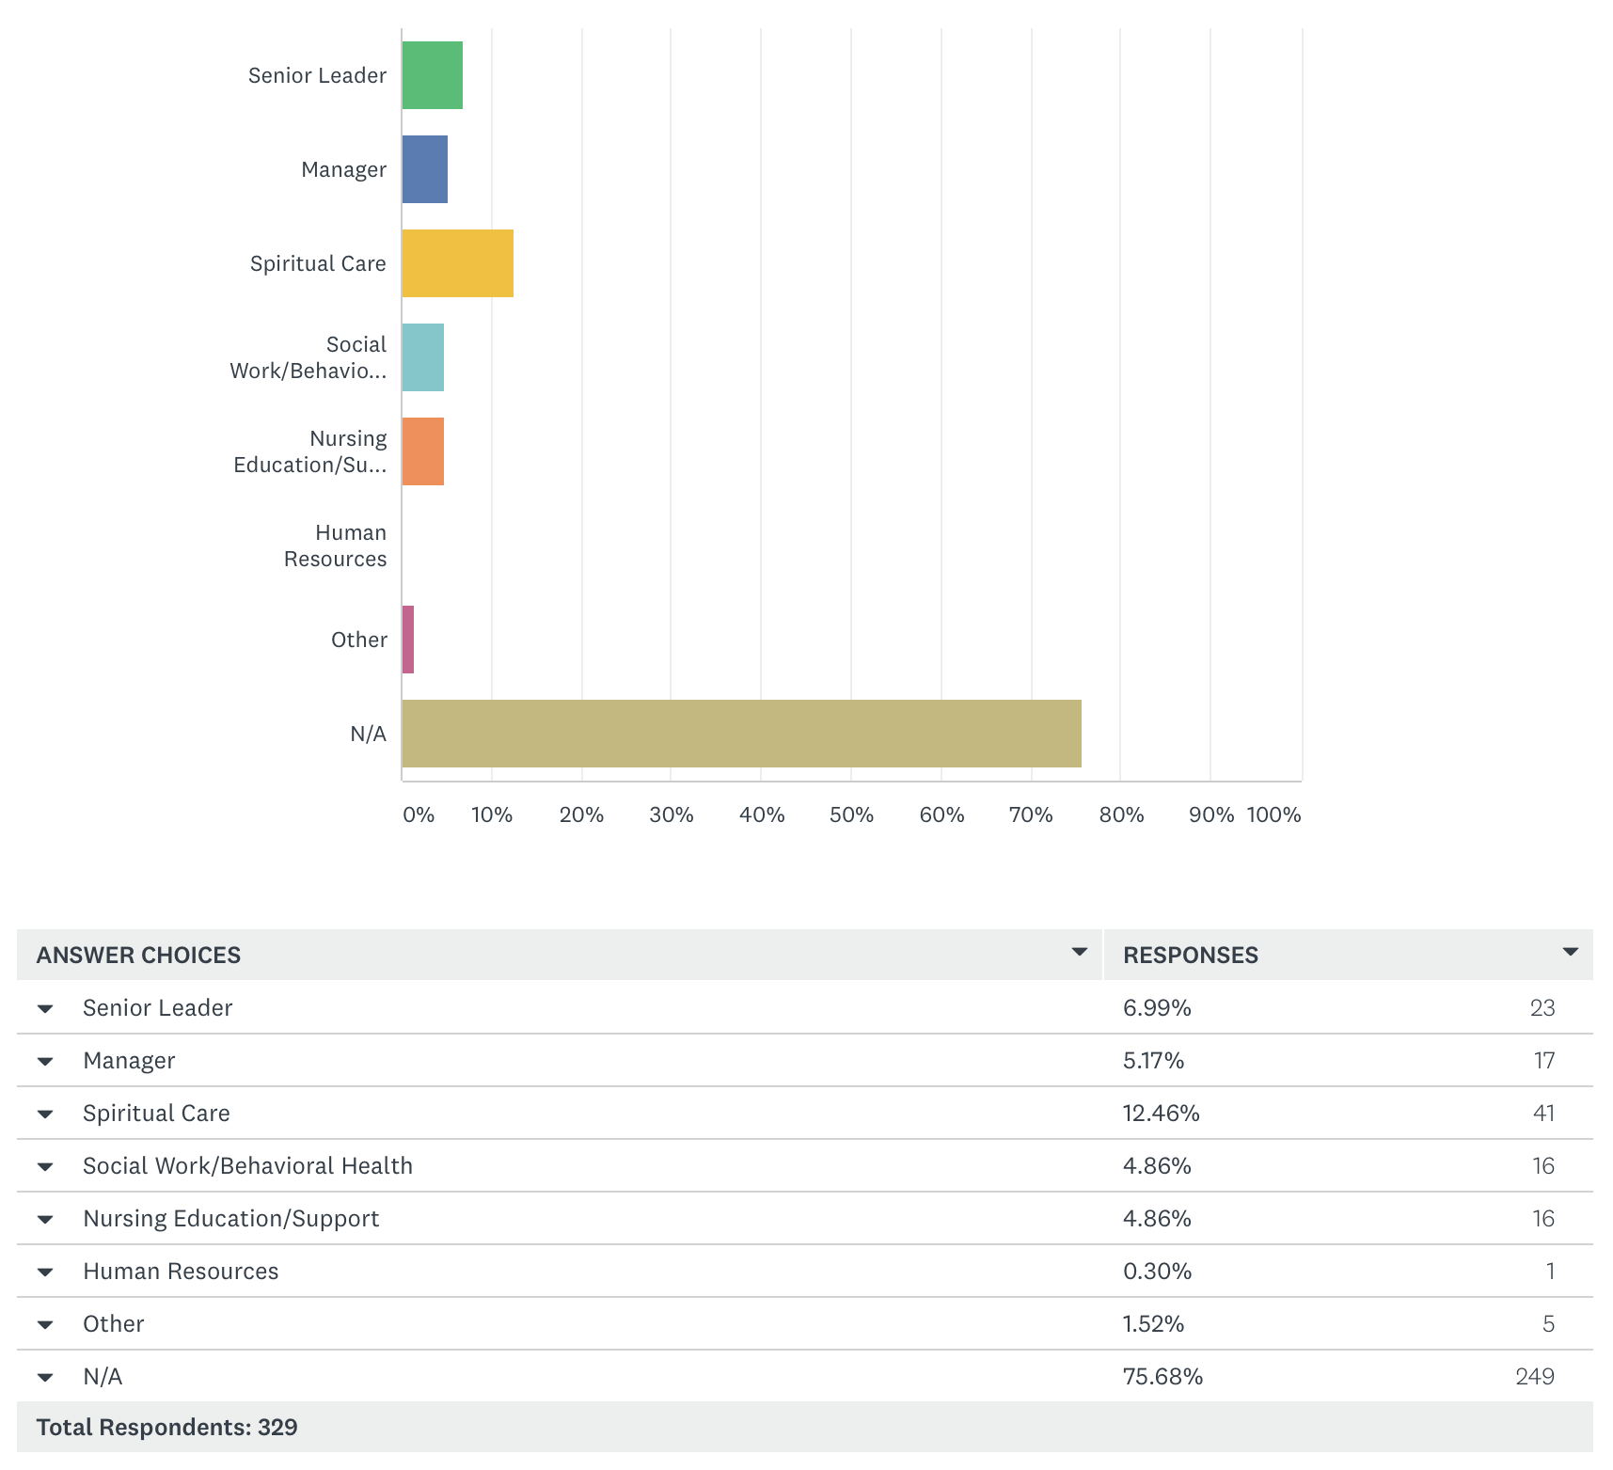

**Q20: Have you utilized any workplace-provided well=being resources due to COVID-19? (Select all that apply.)**

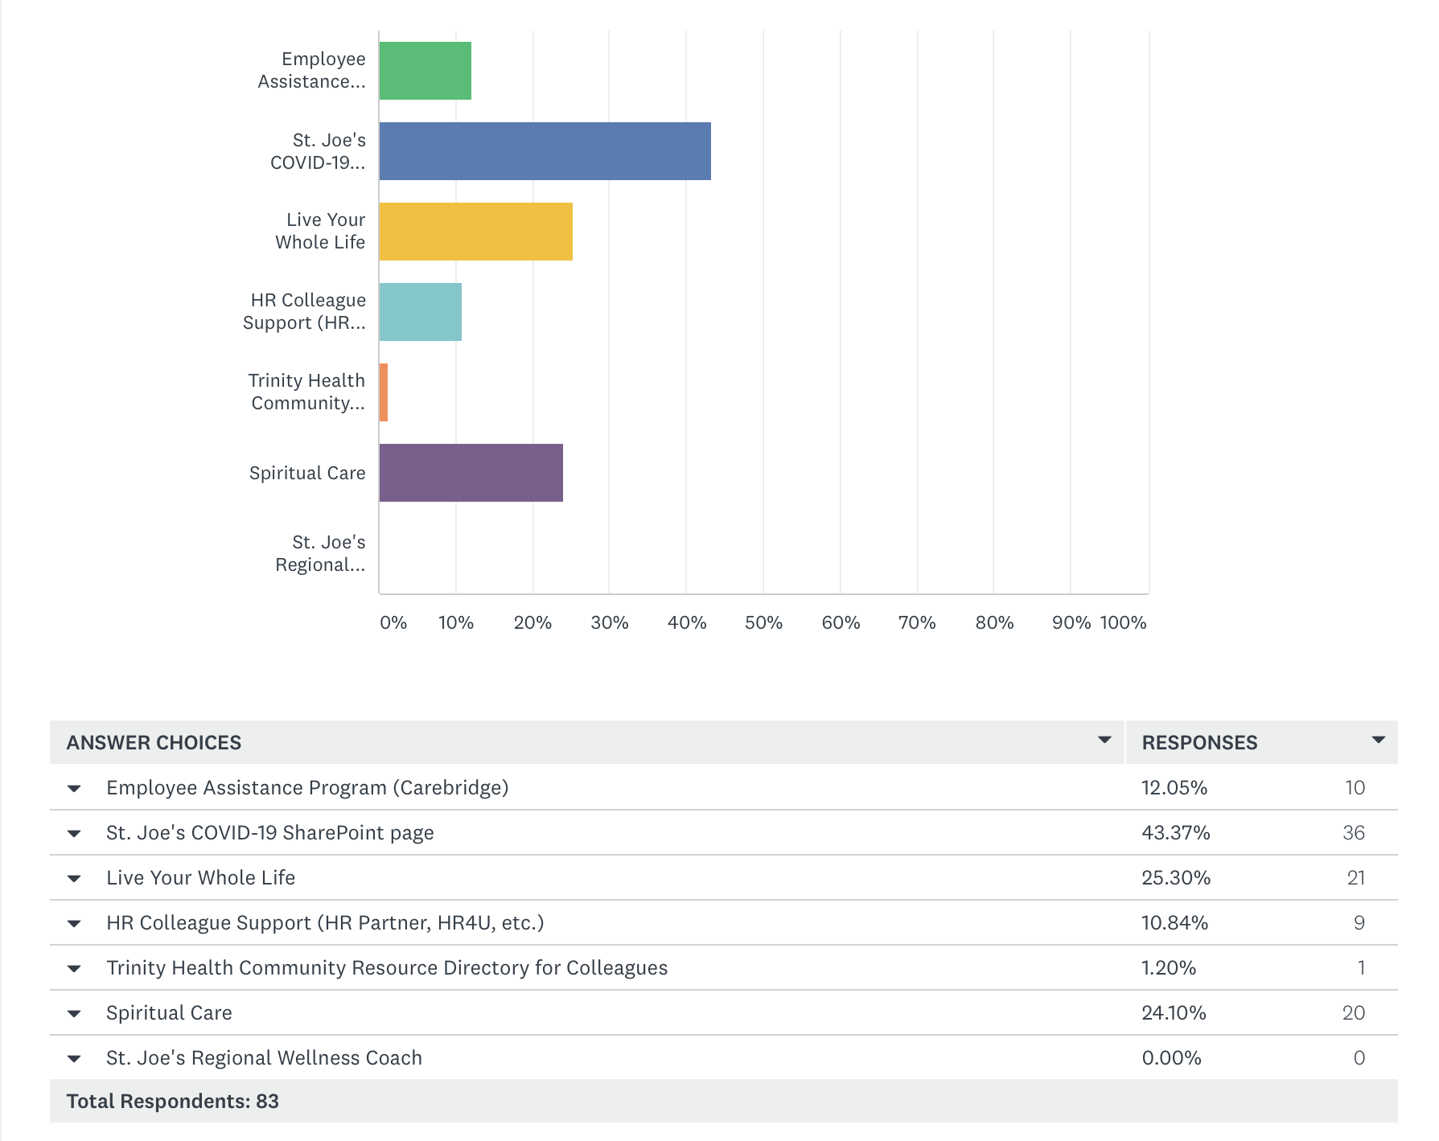

**Q21: Have you accessed any well-being resources/therapies outside of the workplace in response to COVID-19?**

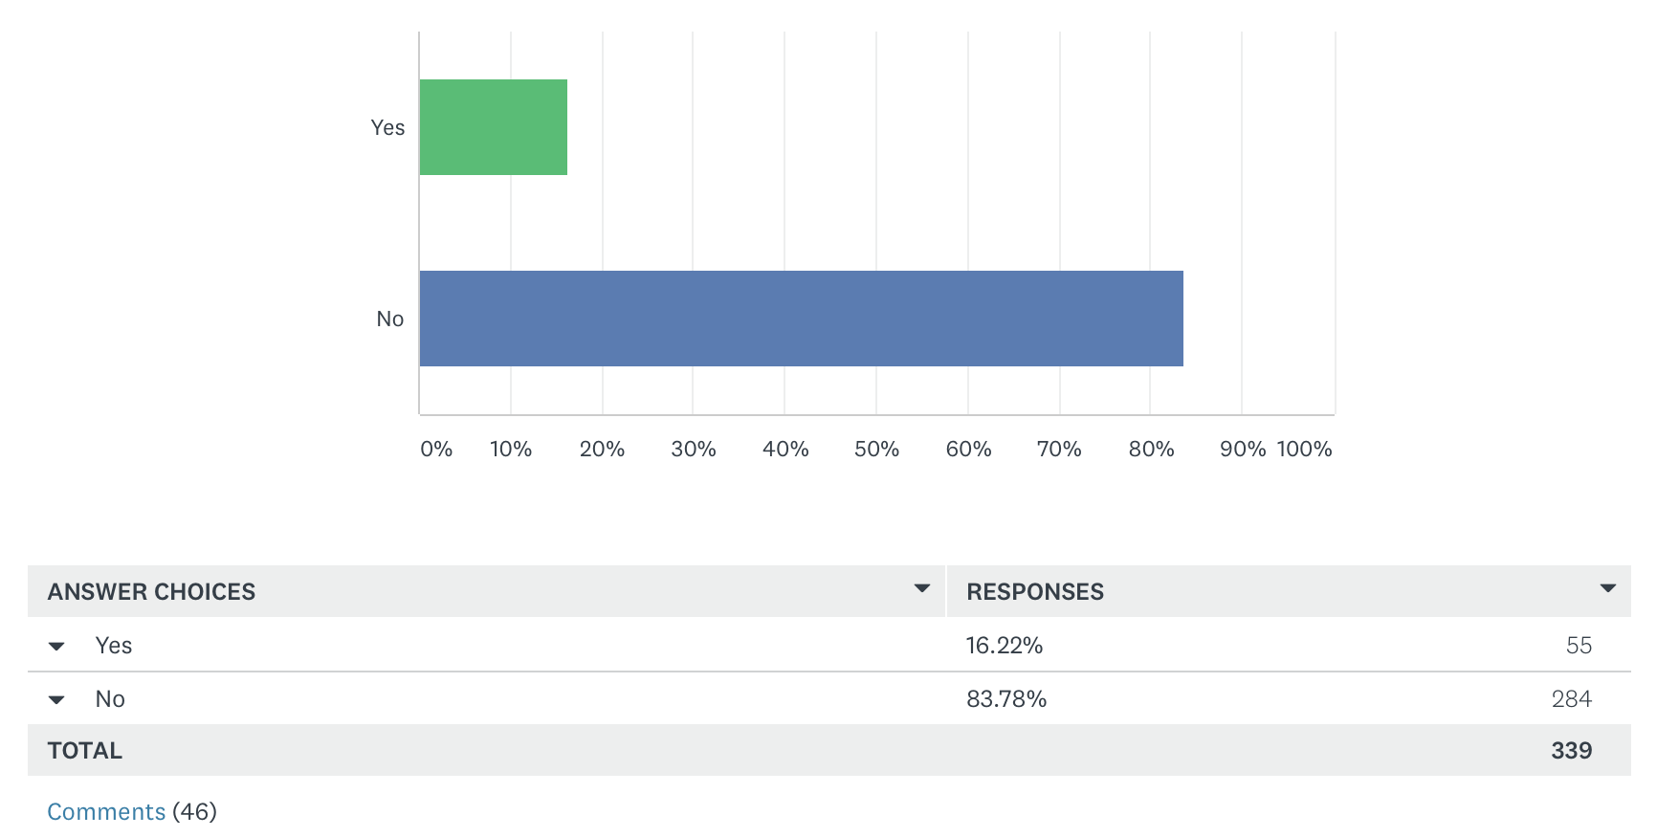

There were 46 free-text responses related to external resources/therapies. Responses included:

* Various forms of individual/private therapies and counseling
* Spiritual learning and/or Cconsultants
* Prescription medications
* Meditation
* Exercise
* Well-Being groups (including nursing groups)
* Video/Online therapy
* Reiki
* Podcasts and apps
* Recreational activities (such as cooking and coloring)
* Mindfulness course
* Prayer
* Yoga

**QUALITATIVE ANALYSIS**

RESILIENCY ROUNDER INTERVIEWS

**Objective:** Todescribe *Resiliency Rounder* perceptions towards the program’s structure, process, and outcomes.

**Themes**

|  |  |
| --- | --- |
| **Variability** | Variability in rounder roles and times to round |
| **Value and Appreciation** | Appreciation from staff, impact and value for Rounders, raising awareness, structured programming from Trinity, giving everyone a voice and a listening ear |
| **Looking Ahead** | Connecting with same staff (reaching new staff), buy-in, making a new “normal”, residual effects (mental health), sustainability, complimenting other rounding |
| **Connection and Teamwork** | Hearing stories, sharing resources, administration to frontline, no agenda, building morale |

**References**

Aiken, L. H., Cimiotti, J. P., Sloane, D. M., Smith, H. L., Flynn, L., & Neff, D. F. (2011). Effects of Nurse Staffing and Nurse Education on Patient Deaths in Hospitals With Different Nurse Work Environments. *Medical Care*, *49*(12), 1047–1053. https://doi.org/10.1097/mlr.0b013e3182330b6e

American Association of Colleges of Nursing. (2019, April). Fact sheet: Nursing shortage.

Anderson, F., Hussey, P., & Petrosyan, V. (2019). It’s still the prices, stupid: why the US spends so much on health care, and a tribute to Uwe Reinhardt. *Health Affairs*, *38*(1), 87–95. https://doi.org/10.1377/hlthaff.2018.05144

Araujo, E. C., & Garcia-Meza, A. (2020, April 7). *World Health Day: The nursing workforce is critical to COVID-19 (coronavirus) and global health*. https://blogs.worldbank.org/health/world-health-day-nursing-workforce-critical-covid-19-coronavirus-and-global-health.

Barkman, S. (2000). Utilizing the Logic Model for Program Design and Evaluation. Lafayette; Purdue University.

Berwick, D., & Fox, D. M. (2016). “Evaluating the Quality of Medical Care”: Donabedian's Classic Article 50 Years Later. *The Milbank Quarterly*, *94*(2), 237–241. https://doi.org/10.1111/1468-0009.12189

Bigbee, L. (2008). Relationships between nurse- and physician-to-population ratios and state health rankings. *Public Health Nursing*, *25*(3), 244–252. https://doi.org/10.1111/j.1525-1446.2008.00701.x

Bodenheimer, T., & Sinsky, C. (2014). From Triple to Quadruple Aim: Care of the Patient Requires Care of the Provider. *Annals of Family Medicine*, *12*(6), 573–576. https://doi.org/10.1370/afm.1713

Brokaw, T. (2020, June 30). Resiliency Rounder Onboarding. Trinity Health.

Chargualaf, K. A., & Elliott, B. (2019). Psychological Effects of Military Service: Applying Research to Civilian & Academic Environments. *The Online Journal of Issues in Nursing*, *24*(3).

Cimiotti, P., Aiken, L. H., Sloane, D. M., & Wu, E. S. (2012). Nurse staffing, burnout, and healthcare–associated infection. *American Journal of Infection Control*, *40*(6), 486–490. https://doi.org/10.1016/j.ajic.2012.02.029

Dempsey, C., & Reilly, B. (2016). Nurse Engagement: What are the Contributing Factors for Success? *OJIN: The Online Journal of Issues in Nursing*, *21*(1). https://doi.org/10.3912/OJIN.Vol21No01Man02

Dyrbye, L. N., Johnson, P. O., Johnson, L. M., Satele, D. V., & Shanafelt, T. D. (2018). Efficacy of the Well-Being Index to Identify Distress and Well-Being in U.S. Nurses. *Nursing Research*, *67*(6), 447–455. https://doi.org/10.1097/nnr.0000000000000313

Dzau, J., Kirch, D., & Nasca, T. (2020). Preventing a Parallel Pandemic — A National Strategy to Protect Clinicians’ Well-Being. *New England Journal of Medicine*. https://doi.org/10.1056/nejmp2011027

Florida Center for Nursing. (2013). (rep.). *The economic impact of Florida’s nursing workforce*. Orlando, FL: Florida Center for Nursing.

Gómez-Ochoa, S. A., Franco, O. H., Rojas, L. Z., Raguindin, P. F., Roa-Díaz, Z. M., Wyssmann, B. M., … Muka, T. (2020). COVID-19 in Health-Care Workers: A Living Systematic Review and Meta-Analysis of Prevalence, Risk Factors, Clinical Characteristics, and Outcomes. *American Journal of Epidemiology*. https://doi.org/10.1093/aje/kwaa191

Grimm, C. A. (2020). (rep.). *Hospital Experiences Responding to the COVID-19 Pandemic: Results of a National Pulse Survey March 23-27, 2020*. U.S. Department of Health and Human Services Office of Inspector General.

Haegdorens, F., Bogaert, P. V., Meester, K. D., & Monsieurs, K. G. (2019). The impact of nurse staffing levels and nurse’s education on patient mortality in medical and surgical wards: an observational multicentre study. *BMC Health Services Research*, *19*(1). https://doi.org/10.1186/s12913-019-4688-7

Kang, L., Ma, S., Chen, M., Yang, J., Wang, Y., Li, R., … Liu, Z. (2020). Impact on mental health and perceptions of psychological care among medical and nursing staff in Wuhan during the 2019 novel coronavirus disease outbreak: A cross-sectional study. *Brain, Behavior, and Immunity*, *87*, 11–17. https://doi.org/10.1016/j.bbi.2020.03.028

Kaysen, D., Resick, P. A., & Wise, D. (2003). Living in Danger. *Trauma, Violence, & Abuse*, *4*(3), 247–264. https://doi.org/10.1177/1524838003004003004

Kelly, L. (2020). Burnout, Compassion Fatigue, and Secondary Trauma in Nurses. *Critical Care Nursing Quarterly*, *43*(1), 73–80. https://doi.org/10.1097/cnq.0000000000000293

Kiser, S. B., & Bernacki, R. E. (2020). When the Dust Settles: Preventing a Mental Health Crisis in COVID-19 Clinicians. *Annals of Internal Medicine*. https://doi.org/10.7326/m20-3738

Lai, Ma, S., Wang, Y., Cai, Z., Hu, J., Wei, N., … Hu, S. (2020). Factors Associated With Mental Health Outcomes Among Health Care Workers Exposed to Coronavirus Disease 2019. *JAMA Network Open*, *3*(3). https://doi.org/10.1001/jamanetworkopen.2020.3976

Lavizzo-Mourey, R. (2013). The human face of hospital readmissions. *Health Affairs*. https://doi.org/10.1377/hblog20130314.029239

Lee, M., Kang, W. S., Cho, A.-R., Kim, T., & Park, J. K. (2018). Psychological impact of the 2015 MERS outbreak on hospital workers and quarantined hemodialysis patients. *Comprehensive Psychiatry*, *87*, 123–127. https://doi.org/10.1016/j.comppsych.2018.10.003

Maben, J., & Bridges, J. (2020). Covid‐19: Supporting nurses' psychological and mental health. *Journal of Clinical Nursing*. https://doi.org/10.1111/jocn.15307

Mayo Clinic. (2018). *Well-Being Index Application*. Well-Being Index. https://demo.mywellbeingindex.org/user/survey.

McAlonan, G. M., Lee, A. M., Cheung, V., Cheung, C., Tsang, K. W., Sham, P. C., … Wong, J. G. (2007). Immediate and Sustained Psychological Impact of an Emerging Infectious Disease Outbreak on Health Care Workers. *The Canadian Journal of Psychiatry*, *52*(4), 241–247. https://doi.org/10.1177/070674370705200406

McHugh, D., Berez, J., & Small, D. S. (2013). Hospitals with higher nurse staffing had lower odds of readmissions penalties than hospitals with lower staffing. *Health Affairs*, *32*(10), 1740–1747. https://doi.org/10.1377/hlthaff.2013.0613

McLeod, S. (2020, March 20). *Maslow's Hierarchy of Needs*. Simply Psychology. https://www.simplypsychology.org/maslow.html.

Mitchell, B. G., Gardner, A., Stone, P. W., Hall, L., & Pogorzelska-Maziarz, M. (2018). Hospital Staffing and Health Care–Associated Infections: A Systematic Review of the Literature. *The Joint Commission Journal on Quality and Patient Safety*, *44*(10), 613–622. https://doi.org/10.1016/j.jcjq.2018.02.002

NSI Nursing Solutions Inc. (2020, March). 2020 NSI National Health Care Retention & RN Staffing Report. NSI Nursing Solutions Inc.

Paavola, A. (2020, August 31). *266 hospitals furloughing workers in response to COVID-19*. Becker's Hospital Review. https://www.beckershospitalreview.com/finance/49-hospitals-furloughing-workers-in-response-to-covid-19.html.

Press Ganey. (2015). The Influence of Nurse Work Environment on Patient, Payment and Nurse Outcomes in Acute Care Settings. South Bend; Press Ganey Associates, Inc.

Rivers, F. M. (2016). US Military Nurses. *Nursing Clinics of North America*, *51*(4), 613–623. https://doi.org/10.1016/j.cnur.2016.07.004

Robert Wood Johnson Foundation. (n.d.). Assessing the Direct Costs of RN Turnover. Robert Wood Johnson Foundation.

Robert Wood Johnson Foundation. (2013, November 18). The RN Work Project . Robert Wood Johnson Foundation.

Roberts, L. B. (2009). The economic benefit of addressing the nursing shortage. http://nursing.illinois.gov/newsrls/2009/42009EconomicBenefitofAddressingNursingShortage.pdf .

Safe and Reliable Healthcare. (2020). *SCORE Integrated Survey*. Safe and Reliable Healthcare. https://safeandreliablecare.com/score-survey.

Scott, R. D. (2009, March). *The Direct Medical Costs of Healthcare-Associated Infections in U.S. Hospitals and the Benefits of Prevention*. Centers for Disease Control and Prevention. https://www.cdc.gov/HAI/pdfs/hai/Scott_CostPaper.pdf.

Scott, S. D. (2015). The second victim experience: mitigating the harm. *American Nurse Today*, *10*(9).

Shanafelt, T., Ripp, J., & Trockel, M. (2020). Understanding and Addressing Sources of Anxiety Among Health Care Professionals During the COVID-19 Pandemic. *Jama*, *323*(21), 2133. https://doi.org/10.1001/jama.2020.5893

Shechter, A., Diaz, F., Moise, N., Anstey, D. E., Ye, S., Agarwal, S., … Abdalla, M. (2020). Psychological distress, coping behaviors, and preferences for support among New York healthcare workers during the COVID-19 pandemic. *General Hospital Psychiatry*, *66*, 1–8. https://doi.org/10.1016/j.genhosppsych.2020.06.007

Sinsky, C. A., Daugherty Biddison, L., Mallick, A., Legreid Dopp, A., Perlo, J., Lynn, L., & Smith, C. D. (2020). Organizational Evidence-Based and Promising Practices for Improving Clinician Well-Being. *NAM Perspectives*. https://doi.org/https://doi.org/10.31478/202011a

Snavely, T. M. (2016). A Brief Economic Analysis of the Looming Nursing Shortage In the United States. *Nursing Economic$*, *34*(2), 98–100.

St. Joseph Mercy Health System. (n.d.). *About Us*. St. Joe's. https://www.stjoeshealth.org/about-us/.

Su, T., Lien, T., Yang, C., Su, Y., Wang, J., Tsai, S., & Yin, J. (2007). Prevalence of psychiatric morbidity and psychological adaptation of the nurses in a structured SARS caring unit during outbreak: A prospective and periodic assessment study in Taiwan. *Journal of Psychiatric Research*, *41*(1-2), 119–130. https://doi.org/10.1016/j.jpsychires.2005.12.006

Suwantarat, & Apisarnthanarak, A. (2015). Risks to healthcare workers with emerging diseases. *Current Opinion in Infectious Diseases*, *28*(4), 349–361. https://doi.org/10.1097/qco.0000000000000183

Tikkanen, R., & Abrams, M. K. (2020, January 30). *U.S. health care from a global perspective, 2019: Higher spending, worse outcomes?* The Commonwealth Fund. https://www.commonwealthfund.org/publications/issue-briefs/2020/jan/us-health-care-global-perspective-2019.

Trinity Health. (2020). *Mission and Values*. Saint Joseph Mercy Health System. https://www.stjoeshealth.org/about-us/mission-and-values.

Well-Being Index. (n.d.). Research Document. mededwebs.com.

Wells, S. (2020). *013 - I've Never Cried Like That About A Patient*. https://nurses.dearworld.org/013-I-ve-Never-Cried-Like-That-About-A-Patient-1.

World Health Organization. (2014). A universal truth: no health without a workforce. World Health Organization.

World Health Organization. (2016, February 10). *Ebola health worker infections*. https://www.who.int/features/ebola/health-care-worker/en/.

World Health Organization. (2019, January 30). *Executive Board designates 2020 as the "Year of the Nurse and Midwife"*. World Health Organization. https://www.who.int/news/item/30-01-2019-executive-board-designates-2020-as-the-year-of-the-nurse-and-midwife-.

Wu, P., Fang, Y., Guan, Z., Fan, B., Kong, J., Yao, Z., … Hoven, C. W. (2009). The Psychological Impact of the SARS Epidemic on Hospital Employees in China: Exposure, Risk Perception, and Altruistic Acceptance of Risk. *The Canadian Journal of Psychiatry*, *54*(5), 302–311. https://doi.org/10.1177/070674370905400504